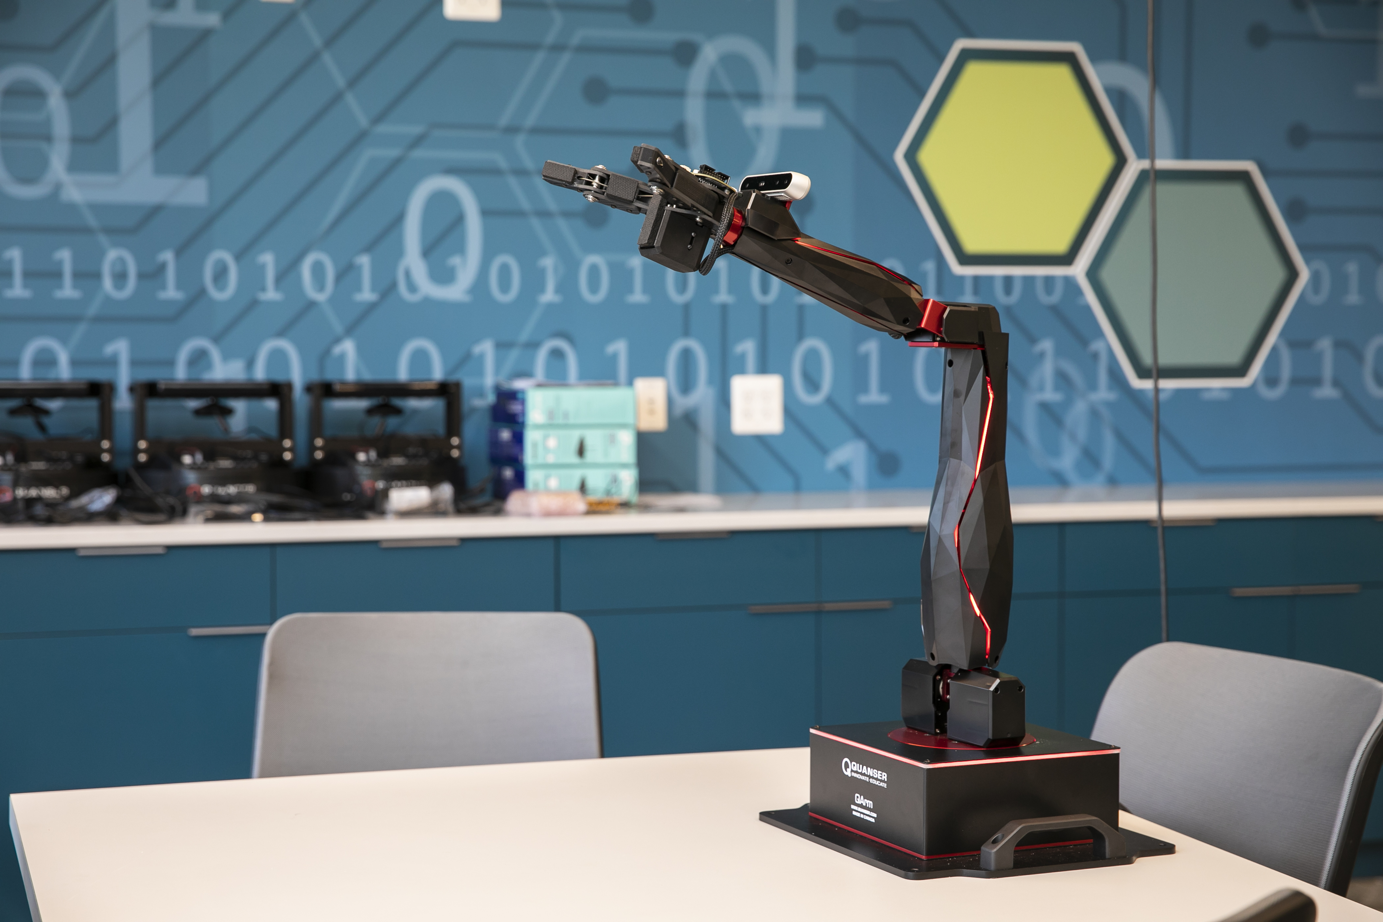

**George Mason University**

8/12/2022

**Summer  
2022**

Amy Lovas

Christopher Smith

David Nguyen

Hrishikesh Karambelkar

**DAEN 690  
Project Report**

**Analysis of Rotorcraft Maneuvers Using Flight Data Monitoring**

**This Page Intentionally Left Blank**

Table of Contents

Abstract 7

1 Introduction 8

1.1 Background 8

1.2 Problem Space 11

1.3 Research 13

1.4 Solution Space 15

1.5 Project Objectives 16

1.6 Primary User Stories: 16

1.7 Product Vision - Sample scenarios (why would someone want to use this) 16

Scenario #1 16

Scenario #2 17

1.8 Definition of Terms: 17

2 Data Acquisition 19

2.1 Overview: 19

2.2 Field Descriptions: 19

2.3 Data Context: 20

2.4 Data Conditioning 23

2.5 Data Quality Assessment: 25

2.5.1 Completeness 25

2.5.2 Uniqueness 25

2.5.3 Accuracy 25

2.5.4 Atomicity 25

2.5.5 Conformity 25

2.5.6 Overall Quality 25

3 Analytics and Algorithms 26

3.1 Physics Based Model – Data Analytics Approach 26

3.1.1 Overview 26

3.1.2 Tuning 26

3.1.3 Predictions 27

3.1.4 Limitations 29

3.2 Machine Learning 29

3.2.1 Data Processing 30

3.2.2 Train the Model 30

3.2.3 Prediction 32

3.2.4 Filter Prediction 32

3.3 LSTM Model (Deep Learning & Artificial Neural Networks) 33

3.3.1 LSTM & Use-cases 33

3.3.2 Data Transformations 33

3.3.3 Training, Testing & Validations 34

3.3.4 Results 35

3.3.5 Opportunities for future expansion 35

4 Visualization 36

4.1 Data Analytics Model 36

4.2 Machine Learning Model Results 38

4.3 LSTM Results 39

4.3.1 Not in Hover & Correctly predicted 40

4.3.2 Hover & correctly predicted 41

4.3.3 Not in Hover not predicted as expected 42

4.3.4 Hover not predicted as expected 43

5 Findings 45

6 Summary 46

7 Future Work 47

8 Appendix A: Code References 47

9 Appendix B: Risk Section 49

9.1 Sprint 1 Risks 49

9.2 Sprint 2 Risks 50

9.3 Sprint 3 Risks 51

9.4 Sprint 4 Risks 51

9.5 Sprint 5 Risks 52

10 Appendix C: Agile Development 53

10.1 Scrum Methodology 53

10.2 Sprint 1 Analysis 54

10.3 Sprint 2 Analysis 54

10.4 Sprint 3 Analysis 55

10.5 Sprint 4 Analysis 55

10.6 Sprint 5 Analysis 55

11 References 56

Table of Figures

Figure 1. Rotorcraft accidents from 1983 to 2018 in the U.S. [1] 9

Figure 2. Accidents by occurrence category [2] 9

Figure 3. Loss of control occurrences [2] 10

Figure 4. Hover taxi task objectives [4] 11

Figure 5. FAA and U.S. Navy air taxi standards [4] [5] 12

Figure 6. Typical data mining methodologies [12] 14

Figure 7. Flight log provided by the FAA 21

Figure 8. Graph of flight log variables vs time 22

Figure 9. Absolute Altitude vs HoverOrNot vs Time 23

Figure 10. Ground speed < 2 24

Figure 11. Ground speed < 1 24

Figure 12. Hover predictions compared to logged time block 28

Figure 13. Hover and right turn confusion matrices 29

Figure 14. Machine learning model flow chart 30

Figure 15. Human activity recognition based on accelerometer [16] 33

Figure 16. Epochs = 10, Sequence length = 500 34

Figure 17. Epochs = 20, Sequence length = 1000 35

Figure 18. GANT Chart of 07 JULY hover maneuver data 36

Figure 19. Latitude and longitude plots of hover maneuvers 37

Figure 20. Physics hover model visualizations 37

Figure 21. Machine learning model results before prediction filtering 38

Figure 22. Machine learning model results after prediction filtering 39

Figure 23. PyPlot of actual and predicted maneuvers in validation data 40

Figure 24. Histogram and heatmap for correctly predicted "Not in Hover" results datapoint - 2 40

Figure 25. Histogram and heatmap for correctly predicted "Hover" results datapoint - 1 42

Figure 26. Histogram and heatmap for "Not in Hover" not predicted datapoint - 6 43

Figure 27. Histogram and heatmap for "Hover" not predicted as expected datapoint - 15 44

Figure 28. Scrum Methodology Timeline 53

Table of Tables

Table 1. Phases of flight based on three state variables [7] 15

Table 2. Hover maneuver parameters 27

Table 3. Physics based model accuracy 28

Table 4. Machine learning model validation set results 32

Table 5. Model accuracy for hover 45

Table 6. Sprint 1 Risks 49

Table 7. Sprint 2 Risks 50

Table 8. Sprint 3 Risks 51

Table 9. Sprint 4 Risks 51

Table 10. Sprint 5 Risks 52

# Abstract

Flight data monitoring software and sensors provide increasing amounts of data to better assess pilot inputs, aircraft parameters, and flight profiling for rotary wing aircraft. Flight data recorders and voice recorders have long been used in accident investigations for fixed wing aircraft. Analyzing sensors assists investigators and researchers in making safety improvements both physically and procedurally. Pilot training is largely reliant on an instructor pilot assessing skills in a pass or fail examination. Utilizing data from flight data monitoring can reduce the subjectivity of these assessments, creating a more consistent expectation for pilot quality and ability. To construct an analytical, data-based approach of evaluation and scoring, a method to identify maneuvers within the datapoints collected throughout a flight must be created. Previous research focused on phases of flights, using decision trees as the process of classification. This paper builds on previous research to identify the time periods of a flight where the aircraft is in a hovering flight profile and particular hover maneuvers within ground effect. This paper focuses on three common data analytic approaches to classify a hovering flight profile: a data analytics approach using physical definitions of maneuvers, a machine learning approach, and a deep learning approach. The physics-based model employs user defined specifications to classify datapoints as a hovering or non-hovering profile. The machine learning and deep learning methods use supervised learning. The machine learning approach analyzes each data point without the memory of the previous data point. The deep learning approach analyzes data-points in order of the maneuver being performed. The results of these analytical predictions compared to the timestamps from the pilot’s flight logs yielded 90-95% accuracy for hover and hover maneuver predictions. This research can further be extended to additional maneuvers and is not limited to the hovering maneuvers.

# Introduction

## Background

Helicopter flight operations are much more complex than fixed wing flight operations. In an airplane, a pilot sets the engine power with the throttle. The inherent design of an airplane is to fly in a straight line with a particular power setting. The pilot uses the single yoke control in front of them to change the direction they want the aircraft to move. A helicopter pilot must use multiple controls all at once to control the aircraft. This makes helicopter flight operations more physically demanding on the pilot and increases the chance for failure or pilot error.

A basic overview of helicopter flight dynamics is explained with Newton’s Law, every action has an equal and opposite reaction. A helicopter has a dynamic weight including its fuel, pilots, passengers and cargo. The main rotor disk on top of the helicopter pushes air downward. This is the thrust produced by the helicopter. Once this thrust exceeds the weight of the helicopter it begins to move upward. The pilot controls this thrust using the collective. This is a control on the left side of the seat. Pulling up on the collective increases the angle of attack, allowing the blade to “catch” more air and push more air. Lowering the collective decreases the angle of attack and pushes less air, decreasing thrust. In addition to the collective, a helicopter also has a throttle that controls the speed of the revolutions of the helicopter’s engines; more revolutions generate more power. These cyclic manipulations alone only allow the helicopter to move straight up and down. The cyclic is the control between the pilot’s legs and operates similarly to the yoke in an airplane. Pushing it forward points the nose of the helicopter down as it tilts the main rotor disk forward. The forward tilt changes the air column from the main rotor from straight down to down and behind the helicopter, thrusting the helicopter forward. Since a portion of the thrust is now pushing the helicopter forward, the pilot must increase collective to stay at the same altitude, until the helicopter reaches an aerodynamically efficient speed called effective translational lift. The spin from the main rotor disk induces torque on the body of the helicopter. According to Newton’s Law, the body of the helicopter will spin equally in the opposite direction of the main rotor disk. The tail rotor prevents the helicopter from spinning and keeps it in a straight line. The pedals control the thrust created by the tail rotor, called anti-torque. A neutral pedal position maintains the helicopter in a straight line. Manipulating the pedals adjusts the anti-torque produced by the tail rotor. More or less anti-torque from the tail rotor caused by pedal manipulation compared to the torque from the main rotor will cause the nose of the helicopter to turn.

Looking at the multitude of inputs a pilot must make for each maneuver it is easy to see that flying a helicopter is a more difficult process than flying an airplane. A helicopter pilot must independently control the inputs of each hand and leg while continuously scanning gauges and maintaining awareness of their surroundings. Helicopters by nature are smaller and operate at lower altitudes than most airplanes. As altitude increases the air becomes less dense and the smaller profile of the rotor blades compared to airplane wings reduces their effectiveness in creating lift. This also means that helicopters spend a greater portion of their time closer to the ground and, as such, closer to hazards created by terrain and man-made obstacles, power lines, cell phone towers, buildings, etc. Looking at helicopter accidents over the last few decades we see a decreasing accident rate across all forms of aviation. Aviation today is generally safer with new technology and software. Fatal accidents, though, maintain relatively unchanged throughout the years. This means that of the proportion of all accidents, fatal accidents in helicopters have increased from 15% to 17.3%. [1]

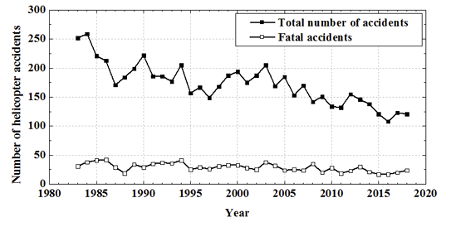

*Figure 1. Rotorcraft accidents from 1983 to 2018 in the U.S.* [1]

This flat trajectory of fatal accidents suggests that accidents that do become fatal are likely due to factors that are inherent to helicopter operations. A 2011 study of the U.S. Joint Helicopter Safety Analysis team looked at 523 accidents. Of these accidents the greatest cause of accidents was a loss of control, accounting for 41% of the accidents [2].

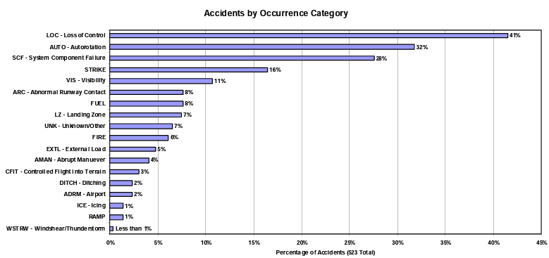

Figure . Accidents by occurrence category [2]

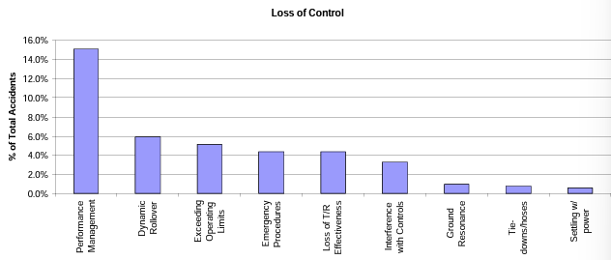

Figure . Loss of control occurrences [2]

Figure 3 shows a further breakdown of the Loss of Control Category. We see the greatest occurrences in performance management and exceeding operational limits. These occurrences are a result of pilots operating outside the safe tolerances of the aircraft.

Mechanical failures accounted for only 28% of the accidents studied [2]. Most helicopter accidents are a result of pilot error. So, how are we training and assessing pilots? The California Aeronautical University website lists the requirements for a private helicopter license. A student must fly a minimum of 40 hours consisting of: 20 hours of flight training with an instructor, 3 hours of cross country flight, 3 hours of night flight, 10 takeoffs and landings, 10 hours of solo time, a solo cross country flight of more than 50 nautical miles, a written test, an oral test, and a final skill test with an FAA-approved examiner [3]. The current methods of evaluating these pilot qualifications are very subjective. The licensing organizations rely on the experience and honesty of the instructor pilots to determine a student is ready for the exam. The FAA-approved examiner is also given a very wide range of subjectivity to determine a student’s efficiency and capability. The FAA produced a Private Pilot Practical Test Standards list of skills. One of the skills is a hover taxi.

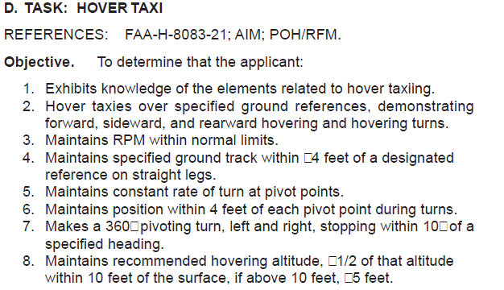

Figure . Hover taxi task objectives [4]

The assessment of the hover taxi maneuver is very subjective. Some of this is necessary, RPMs will vary based off the weather, type of aircraft, load, etc. Therefore, the regulation cannot be too specific. Other metrics, like maintain ground track within 4 feet while at an altitude of 10 feet or higher, will be a difficult measure for an evaluator riding in the helicopter to judge. One evaluator may naturally hold students to a higher standard, while another may be more lenient.

Is there a better way to judge prospective pilots while ensuring a baseline standard is met? Flight data recorders continually record flight parameters during flight. Altitude, pitch, yaw, position of the collective, position of the main rotor disk, torque, etc. are all recorded through the duration of the flight. By evaluating this data, we may be able to identify maneuvers the pilots are performing and apply an objective scoring of the pilot’s ability to perform these required maneuvers and identify when the student is exceeding safe parameters.

## Problem Space

A challenge for rotorcraft operations is the lack of consistency across manuals for defining a maneuver. Definitions of individual maneuvers vary greatly. Figure 5 shows the definitions for Air/Hover Taxi from the FAA and the U.S. Navy [4] [5]. The FAA breaks Hover Taxi into two separate maneuvers, Hover Taxi and Air Taxi. The Navy identifies them as the same for their standards. The FAA does not list a speed for the maneuver, relying on a safe assessed speed. The Navy lists less than 20 knots for hover taxi and more than 20 knots for air taxi. The FAA lists no altitude restrictions for either maneuver. The Navy lists an altitude restriction of less than 100 feet for both maneuvers. We can further complicate the definition by looking at the webpage for the Los Angeles Air Route Traffic Control Center. While on the airport the ATC lists hover taxi/air taxi closely in line with the Navy. With a speed greater than 20 knots and less than 100ft of altitude [6]. A problem can arise with the lack of clarity in definition. If a pilot is trained under the FAA Practical test standards that do not specify an altitude or speed, an air traffic controller may give a direction they expect the pilot to follow but the pilot may know a different standard. For supervised learning approaches, labeling the data is more challenging without a clear definition and unsupervised approaches will need a larger pool of samples to account for the variances of the same maneuver.

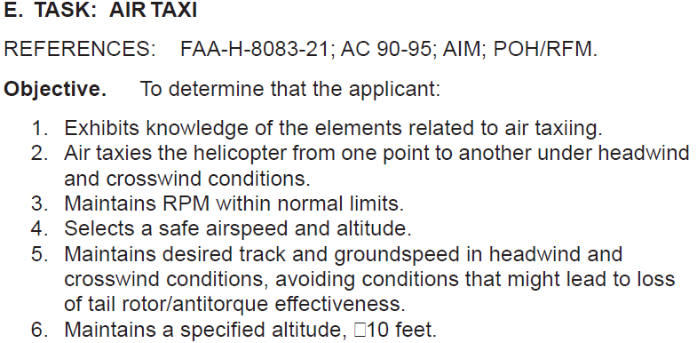 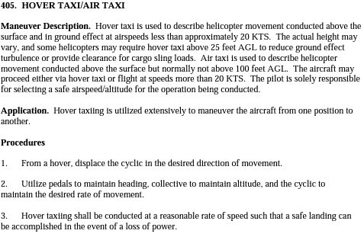

Figure . FAA and U.S. Navy air taxi standards [4] [5]

With the possibility of varying degrees of expectations and grading by instructor pilots during evaluations, it has been identified that one of the potential ways to decrease the number of fatal accidents is to find ways to standardize the evaluation process. Student pilots and instructor pilots have a heavy workload during an evaluation flight to ensure that every required maneuver is covered, the safety of the aircraft and its occupants is maintained, proper communication with air traffic control and other aircraft is executed, and all aircraft limitations and standards are met. It is probable that an instructor pilot may not catch every error that a student makes during an evaluation flight.

To assist with this problem, the Federal Aviation Administration (FAA) proposes that is possible to use the parameters collected and recorded by the flight data recorders to assist in defining and evaluating helicopter maneuvers.

Analyzing the data and parameters of an aircraft and its gauge readings, position of the flight controls, length of time of aerodynamic conditions, and other collected data, it is possible that machine learning can assist in categorizing different key times during a flight evaluation to assist time-labeling portions of a flight. If this can be achieved, required maneuvers can be analytically labeled for better analysis and more consistent grading.

The goal of our analysis and this paper is to create an analytical process to tag simple maneuvers, such as a hover maneuver. If we can create a method to time-label hover maneuvers, the same process can be repeated to eventually time-label all required flight maneuvers in a pilot’s evaluation. Once the tagging process is complete, an entire evaluation flight could be run through the analytical process, key maneuvers that require grading can be labeled with a start and end time in the flight data recorder, and the required parameters can be more objectively and technically assessed by further analysis to determine the proficiency and capability of the pilot.

Our team will be starting with simple hover maneuver analysis to determine the best process for maneuver tagging in a length of flight recorder data. There are three key hovering maneuvers that we will attempt to create a time-labeling method that will assist in producing the process of maneuver tagging on the flight recorder timeline:

* Hover Pedal Turns: In a pedal turn, the pilot turns the heading of the aircraft about the main rotor head while maintaining the same altitude. Because the center of the rotor head is relatively in the center of the airframe from nose to tail, the center point position of the aircraft will remain relatively constant. Ultimately, the only position that changes is the heading direction of the nose of the aircraft. The heading should change at a constant rate until the aircraft comes to a stop at the new heading at the end of the turn.
* Lateral Hover/Hover Box: In a lateral hover, the pilot conducts a “sliding” hover maneuver from one position to another. The heading and altitude of the airframe remain the same throughout the maneuver. The aircraft will either move forward, left, right, or backward. Generally, the velocity of the aircraft is less than 20 knots.
* Hover About a Point: While hovering about a point, the pilot points the nose of the aircraft to a fixed position and circles about the point while maintaining altitude. The imaginary radius of the circle being drawn by the nose of the aircraft around the fixed point in space will be the same throughout the maneuver. Imagine circling around a large boulder while continuing to face directly toward the boulder and maintaining and equal distance between the nose of the helicopter and the boulder. The heading should have a constant rate of change and, generally, the velocity of the aircraft is less than 20 knots.

Because several iterations of these maneuvers can be conducted in the simulator in a relatively short period of time, they are a good starting point in identifying the best procedure for analytically tagging the start and end times. This will allow us to use a training set with given start and end times of the maneuvers so we can identify the most accurate identification method. We can then apply the selected identification and time tagging method to an unlabeled data set to pick out specific maneuvers from the flight data recorder. Once the maneuver identification and start and end time tagging methods are created, a grading scheme can be applied to the recorded data within the maneuver timeframe to determine an objective performance grade.

Though these are only three of the several maneuvers that are performed and assessed during a flight evaluation, it is a great start in standardizing pilot qualification testing using data analytics.

## Research

This project builds upon previous work conducted by the Federal Aviation Administration, the Georgia Institute of Technology, and the University of Maryland Global Campus. Previous work focused on identifying phases of flight [7], identifying and scoring approaches [8] [9], and developing event definitions [10]. Once phases or maneuvers are identified in flight, researchers are able to study maneuvers to make aircraft safer [11].

Published research on this topic primarily focuses on physics-based models or data mining methods. Gavrilovski uses physics-based models to predict when inputs will exceed structural or aerodynamic limits [10]. Goblet uses physical parameters of airspeed and altitude to identify phases of flight in fixed wing general aviation [11]. Chin tested a variety of the most popular data mining methodologies and found a Sliding Window Regression Classification and a filtering approach produced the best results for Rotorcraft phases of flight [7]. Though challenges with aviation data exist, the increased use of Flight Data Monitoring sensors allows researchers to apply modern data mining. An overview of typical data mining methodologies is shown in Figure 6.

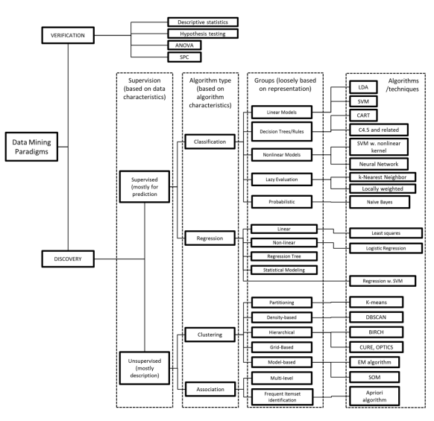

Figure . Typical data mining methodologies [12]

The challenge with applying traditional data mining methods to aviation data is that most methods rely on data that is independent and static while aviation data is a time series [12]. As discussed earlier, inputs to one control surface will affect the others. The pitch of a blade at one timestamp is dependent on the pitch of the blade at the previous timestamp and the change of other factors, for example.

The phases of flight defined by the International Civil Aviation Organization and the European Coordination Centre for Accident and Incident Reporting System may not be suitable for rotorcraft maneuvers and are not quantified using appropriate metrics [7]. Without a measurable definition for the phases of flight, it is difficult to categorize data around it. This paper assumes phases of flight based on the 3 state variables, shown in Table 1.

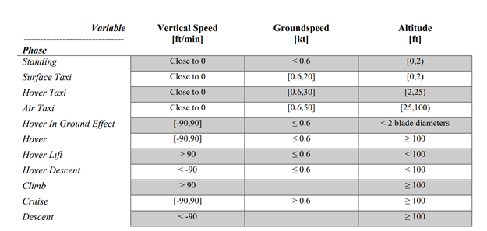

Table . Phases of flight based on three state variables [7]

The goals of this paper are to enrich the hover stages defined in this table with additional variables and define complex maneuvers as a correlation of the above-defined parameters with each other and with time. Potential algorithms suitable for such analysis are:

1. Time-Series Temporal Clustering

Factorize time series into segments that belong to different temporal clusters [13].

1. Model Time-Series data with Linear Regression

Build a regressor matrix of current and past observations of predictors ordered by time and apply ordinary least squares to the multiple linear regression model [14].

1. Long Short-Term Memory – Deep learning model associated with sequences.

## Solution Space

To address this problem, the team will use a data exploration approach to visualize the changes in the variable throughout the recorded flight timeline to identify obvious variables that would have the most influence on predicting the hover maneuvers. In this case, it could be the altitude and moving speed of the helicopter. Then, our team will investigate segmenting the data into a time-series-based model to capture the changes of variables throughout the time and predict the hover maneuver within the timeline of the recorded flight. After this, the team will be looking into different machine learning models to predict the three different types of hover maneuvers that we would like to be able to analytically identify.

## Project Objectives

Working on this project will teach our team how to apply different parameters to a dataset and create classifications based on a set of given rules and expected values and relative characteristics that some variables may have during a time in space. This is important because to evaluate a flight maneuver analytically using data rather than based on an instructor’s judgment, the analytical process must properly identify not only the maneuver being performed, but the timeframe in which it is occurring. We will start with the simplest hover maneuver first, hovering in place. Then, we will apply the same method to the three hovering maneuvers outline in section 1.2: Hovering Pedal Turns, Lateral Hover/Hover Box, and Hover About a Point. If we can properly and accurately identify and label these three maneuvers, our analytical process can be applied to other required maneuvers in a flight evaluation.

If we are successful, this process can assist instructor pilots to better evaluate a student pilot’s abilities using subjective data. Hopefully, in the long run, this can lead to a more consistent training level and less fatal accidents in the helicopter community.

## Primary User Stories:

Based on the user context and value proposition, we developed the following primary user story to guide our project:

”As the senior instructor pilot at the University of North Dakota flight school, I want to be able to assess my junior instructor pilots’ abilities to ensure they are producing consistent, safe, and efficient pilots from our program by holding all of our students to the same, objective standards. Because of the ability to pull aircraft data and parameters from the flight data recorder and identify the time-period where the evaluated maneuvers were being performed, we can objectively assess each student’s flight maneuvers on a consistent grading scale. This has significantly improved our ability to ensure each pilot that leaves our school can perform at the same level expected of a pilot with a rotary wing license from the FAA.”

## Product Vision - Sample scenarios (why would someone want to use this)

### Scenario #1

* For: Flight training standardization in evaluations and qualifications
* Who: Instructor pilots and flight evaluators
* In Order To: Ensure a standardized expectation and capability in pilots that are certified and licensed to fly rotary aircraft by the FAA
* Unlike: Currently pilots are graded by instructor pilots that may have different objective grading scales, producing a variance in pilot capabilities that hold rotary aircraft piloting licenses
* Our Product: Will allow for post flight evaluation on an objective level that can identify the key required maneuvers during an evaluation flight and eventually provide an objective grading scale for the pilot’s performance
* Caveats: Machine learning and computer analytics may not be 100% accurate in identifying and classifying maneuvers every time and could either miss an unsafe maneuver if it is so far outside of regulation performance that it is not recognized, resulting in a pilot being passed when they should have failed.

### Scenario #2

* For: Post accident investigations
* Who: Accident investigators that may be trying to identify which maneuver was being conducted that lead to an accident and the parameters and flight profile that could have led to the accident
* In Order To: Conduct a post-accident analysis using the flight data recorder to identify and categorize the flight maneuvers and conditions that were present leading up to and during the accident so we can have a better understanding of what happened and how to prevent future accident occurrences, either through pilot training or aircraft improvement.
* Unlike: Currently trying to re-create the accident scene based on radio recordings or aircraft paths that could lead to an inaccurate representation of what happened leading up to and during the accident.
* Our Product: By identifying the maneuvers that are occurring in a time continuum throughout the flight, could potentially lead to a better ability of identifying what the pilot was doing at the time of accident occurrence.
* Caveats: Machine learning and computer analytics may mis-interpret parameters due to outside environmental factors that may have contributed to the accident, potentially creating a misleading belief that a pilot was conducting one maneuver but was conducting a different maneuver leading up to the accident.

## Definition of Terms:

Anti-torque Pedals – Pedals, at the feet of the pilot, control the amount of thrust generated by the tail rotor to counteract the spin induced by the main rotor head

Collective Pitch Control – Controls the Revolutions Per Minute and angle of attack of the main rotor disk

Cyclic Pitch Control – Tilts the main rotor disk in the direction the pilot wants to move the aircraft

Hover – For the purposes of this project, defined as an altitude between 2 and 50 feet with a ground speed up to 5 knots, and an altitude differential no greater than 12 feet. (See Table 2 for parameters)

Hover Taxi – For the purposes of this project, defined as an altitude between 2 and 50 feet with a ground speed between 5 and 20 knots, and an altitude differential no greater than 12 feet. (See Section 1.2, Lateral Hover/Hover Box, for description)

Pedal Turn – For the purposes of this project, defined as an altitude between 2 and 50 feet with a ground speed up to 2 knots, an altitude differential no greater than 12 feet, and a heading change of at least 10 degrees. (See Table 2 for parameters or Section 1.2 for description)

Turn About a Point – For the purposes of this project, defined as an altitude between 2 and 50 feet with a ground speed between 2 and 5 knots, an altitude differential no greater than 12 feet, and a heading change of at least 10 degrees. Additionally, the longitudinal and latitudinal differences must be between 0.0002 and 0.0006. (See Table 2 for parameters of Section 1.2, Hover About a Point, for description)

# Data Acquisition

## Overview:

Each Thursday from 9 June 2022 through 21 July 2022 two pilots conducted training in a helicopter flight simulator that uses a combination of parameters from the Sikorsky S76 and the AgustaWestland AW139. The Rotorcraft Analysis Recording (RoAR) data contains 108 predictors with a sampling rate of approximately 0.02 seconds. Our team had to manually add maneuver labels to the data since the data set only collects the 108 parameters for each time reference without associating the parameters to a phase of flight, flight profile, or a specific maneuver. A brief overview of the predictors that will be important in our dataset for creating a maneuver prediction method are identified in section 2.2.

## Field Descriptions:

Of the 108 parameters recorded for each data point by the RoAR, below are the field descriptions for the predictors pertinent to our analysis and flight maneuver predictions [15].

* date_time (Type: datetime) – Date of the data point in format DD/MM/YYYY and time stamp of the data point in format HH:MM:SS.MM
* latitude (Type: float) – Rotorcraft latitude
* longitude (Type: float) – Rotorcraft longitude
* absoluteAltitude (Type: float) – The altitude above ground level where derived from means other than radar-based altitude equipment, in which case the altitude would be more directly considered the “radio altitude”.
* trueHeading (Type: float) – Heading that is relative to the geographic poles. True Heading equals true course ± wind correction angle.
* groundspeed (Type: float) – Horizontal speed of the aircraft relative to the ground. Ground speed can be determined from (1) GPS, (2) radar or (3) corrected true airspeed accounting for wind.
* trueAirspeed (Type: float) – Corrected calibrated airspeed for air temperature and atmospheric pressure variations.
* climbOrDescentRate (Type: float) – The climb or descent rate (i.e., altitude rate or inertial vertical speed), indicates whether the aircraft is climbing, descending, or in level flight; e.g., indicated by vertical speed indicator (VSI) (e.g., barometer)
* hasWeightOnWheels (Type: binary) – The value of whether the helicopter currently has weight pressure on the wheels or not. The value of 1 would indicate the wheel currently resting on the ground or landed on the ground. The value of 0 would indicate the wheels are currently in the air and do not have any weight pressure on the wheels.
* turnRate to degPerSec (Type: float) – Rate of change of aircraft heading.
* cyclicPositionPitch (Type: float) – Neutral is zero. Aft is by positive percentage. Forward is by negative percentage.
* cyclicPositionRoll (Type: float) – Neutral is zero. Right is by positive percentage. Left is by negative percentage.
* collectivePosition (Type: float) – Full-down/Neutral is zero. Up is by positive percentage.
* antiTorquePedalPosition (Type: float) – Neutral is zero. Right is by positive percentage. Left is by negative percentage.
* throttlePosition (Type: float) – Rotorcraft throttle position.
* e1Torque (Type: float) – Percent of torque.
* e2Torque (Type: float) – Percent of torque.
* pitch (Type: float) – Rotation on the y-axis; aircraft pitch attitude.
* roll (Type: float) – Rotation on the x-axis; aircraft roll attitude.
* yaw (Type: float) – Rotation on the z-axis.

## Data Context:

The data was collected through rotorcraft simulations performed by an FAA pilot and analyst in a helicopter simulator which combines parameters from the Sikorsky S76 and the AgustaWestland AW139. As part of the simulation, the pilots performed several maneuvers and recorded this data from the simulator using the Rotorcraft Analysis Recording (RoAR) parameter fields into a JSON file. The data collection uses specifications from the version 0.1.18 RoAR system. Throughout the simulated flight, the pilot announced the maneuver they were about to perform and a recorder manually wrote down the maneuver name, orientation if applicable (left, right, clockwise, counterclockwise, ect.), and the start and end time for each maneuver. In the real world, this data would be collected from the flight data recorders on the rotorcraft. The maneuvers that required analysis – “Hover Pedal Turns”, “Lateral Hover/ Hover Box” and “Hover About a Point” were performed several times and labeled for the time duration in the dataset.

With the hand-written flight log provided and the dataset, the team used several python data manipulation techniques to group all the datapoint from 0.02 milliseconds to seconds. Then, we extracted only the variables that we were interested in and added new columns to identify whether the data point is hover or not, hover pedal turn left, hover pedal turn right, hover about a point clockwise, or hover about a point counterclockwise. Then we created several plots to understand the effect of absolute altitude and ground speed on the added variables/columns.

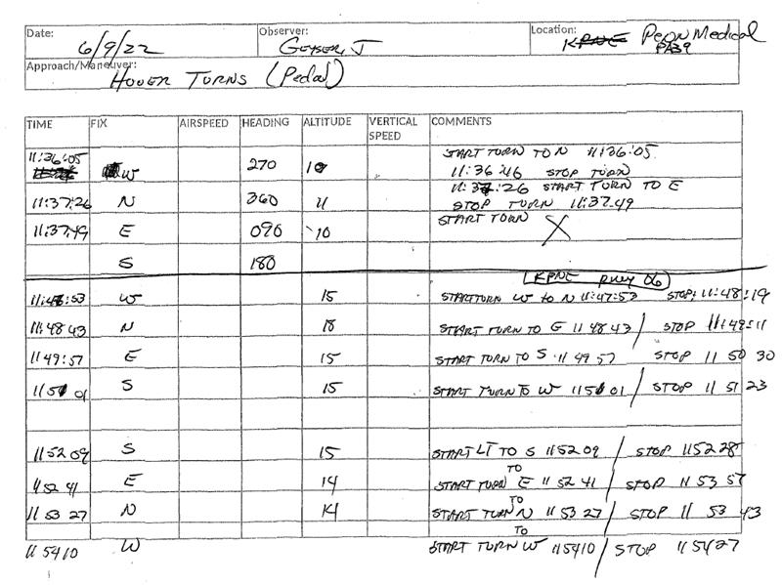

Figure . Flight log provided by the FAA

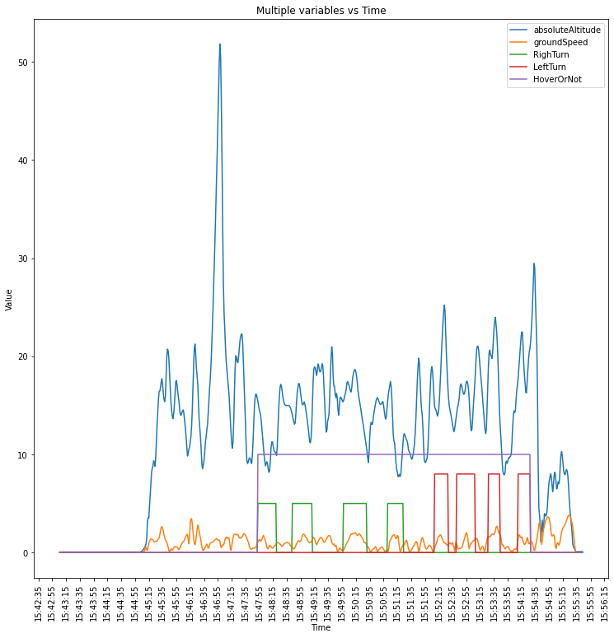

Figure . Graph of flight log variables vs time

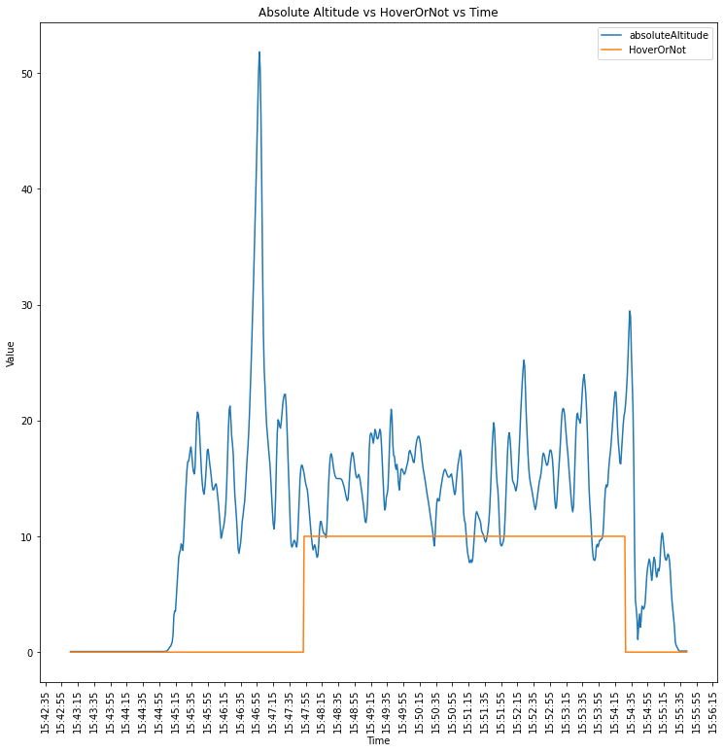

Figure . Absolute Altitude vs HoverOrNot vs Time

With this valuable information that the team learned from these plots, we developed a set of rules that could help eliminate the manual effort of labeling the dataset for training purposes. After this, the team will use these training datasets to train the machine learning model to detect the period when the helicopter is in a hovering profile versus when the helicopter is not in a hovering profile.

## Data Conditioning

For each data set the team was provided there are two files: the CSV file of the flight sensor data and the handwritten flight logs. The data sampling occurs approximately every 0.02 seconds. This poses a challenge to the team as a 30 second span of time contains about 1200 data samples. With this high sampling rate, the team needed to derive some statistics to draw relevant conclusions. First the data was read using a combination of date and time as the index. Reading in the CSV this way allows time series functions to easily integrate with the data. The rolling function in pandas was used for varying periods of time to calculate differences in values. For example, a right turn would involve the helicopter turning clockwise, this would result in a positive heading change, for example from 90 degrees (East) to 180 degrees (South). Conversely, a left turn would derive a negative value turning counterclockwise. With the rolling function and a window set to three seconds, we calculated the change in heading over the next three seconds at each given data point. If this value was positive, then it suggested a right turn. The challenge with this was determining a time period that made sense but does not shift the data. A large window could bring in data points to the left of the turn and cut off values at the end, as the next few seconds would have a very small difference at the end of the turn. The team focused on physics-based predictors based on the wishes of the project sponsors. In this project, the goal was to create a product that can be used across several platforms and environments. Using more nuanced predictors like main rotor disk pitch would vary given the operational parameter of the model of helicopter and environmental conditions, such as crosswinds, temperature, or atmospheric pressure. From the Practical Test Standards and the Helicopter handbook the dataset is sliced to identify when conditions for the maneuver exist.

Using these methods, we compared the results from our functions to the plotted flight log data. The functions predict more hover periods and pedal turns than the flight logs display. Unfortunately, for this data set, there is not much variance in the data. The methods need to be tested over a larger data set with a greater variation in flight profiles. Also, we need to look at additional predictors and the values that we decided to use. For example, changing the ground speed to less than 1 greatly reduces the number of hovers outside of the hover window, but decreases the performance of the hover turns, as turning shows an increase in ground speed.

The lack of variance in the flight profile is seen in the ground speed and altitude data. We assume that there is some disconnect between the flight logs and what the data is showing. Depending on the takeoff profile, taking off can look a lot like some of these hover maneuvers. The next step is requesting a more varied dataset from the simulator, where the pilot immediately takes off then comes back for a hover, then assumes another task and comes back for another hover. With this variance we may be able to see if our methods are working or if we need to look at other predictors.

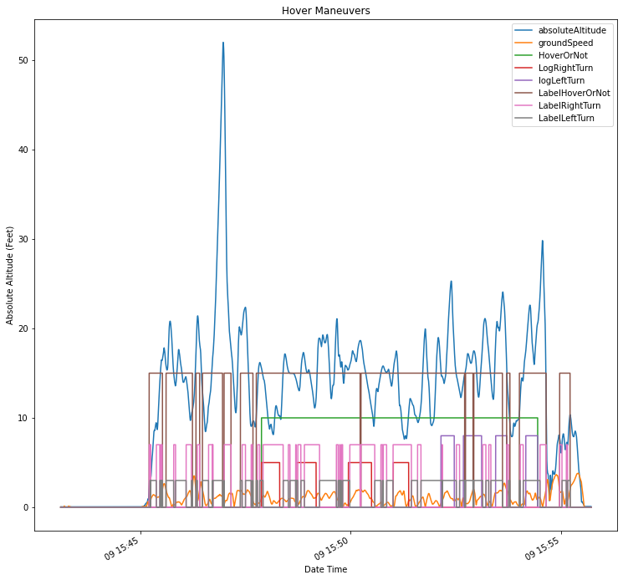

Figure . Ground speed < 2

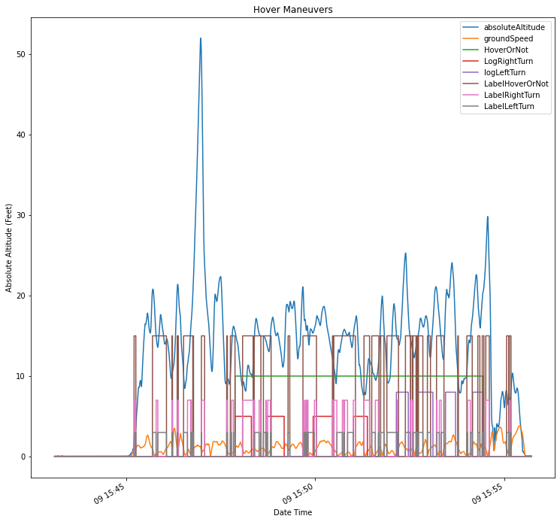

Figure . Ground speed < 1

## Data Quality Assessment:

### Completeness

The benefit of simulator data is that our data is mined as required. Of the hundreds of thousands of sample points that the dataset contains, there are zero null values. For our models to work effectively in the real-world, our dataset needs to be enriched with naturally occurring maneuvers during a pilots’ training hour.

### Uniqueness

Multiple sensors collect information that overlaps with predictors (true vs. indicated airspeed vs. ground speed, GPS altitude vs. absolute altitude vs. altimeter). The problem with aviation data is it is not independent. These different altitude readings consider different factors. Therefore, we have three separate values for one position in space. The data can be grouped by the time instance which would be the indicator for uniqueness.

### Accuracy

One of the issues the team faces is the accuracy of the handwritten flight log. At the current sampling rate, the data is too minute to draw meaningful conclusions. We need to derive averages or movements over time which will reduce accuracy of measurements. In addition, the flight logs are not to the same level of accuracy as the sampling rate, therefore we will lose fidelity when adding labels to the start and end of the maneuver to the dataset. The flight logs are handwritten entries which occasionally do not coincide with the data from the simulator.

### Atomicity

Atomicity might be of concern if the flight logs have missing maneuvers, but the simulator data indicates that a maneuver has been performed. Using these flight logs for testing might lead to errors.

### Conformity

The simulated data conforms to the conventions used in aviation space for the Flight Data Recorder.

### Overall Quality

The overall quality of the data can be considered complete. The benefit of using simulator data is the reproducibility of exact weather, aircraft, and pilot maneuvers without considering environmental factors. However, the effects of environmental factors on maneuvers are out of scope of this research and the model can only be used when pilots are training on simulators indoors.

# Analytics and Algorithms

## Physics Based Model – Data Analytics Approach

The first model attempted is a physics-based model. This is a rule-based model that relies primarily on helicopter aerodynamics and parameters determined by subject matter experts and test standards published by the Federal Aviation Administration [4] [5]. This model attempts to address the challenges associated in applying data mining techniques to flight data monitoring identified in Gavriloski [12]. Gavriloski identified that varied nature of rotorcraft flight plans results in more varied flight plans and a lack of homogeneity across sensors and automation [12]. In short, it is harder to predict the next phase or maneuver of a helicopter pilot, then a commercial 737 pilot. Therefore, this physics-based model attempts to define maneuvers based on parameters that will not change based on a given aircraft or sensor suite. It is assumed that if a helicopter has a flight data monitoring system, they will have the ability to record physical parameters such as altitude, heading, and speed.

### Overview

The model scans the dataset for conditions that represent the maneuver. For instance, a helicopter in a hover has a very small change in altitude, it is not on the ground, and change in geographical coordinates is near zero for a stationary hover. Using rules to define the maneuvers allows the user to apply the model in varying weather and physical environments, regardless of aircraft type. These parameters are calculated using rolling windows in pandas. The length of the window is determined by the maneuver and how long after a pilot’s input translates to a physical movement of the aircraft. This function results in a change in parameter over time for each individual data point. Choosing parameters that are somewhat independent of specific helicopter parameters or engine settings allows the model to be used in a variety of conditions. A helicopter with no wind effects may have a hover with a main rotor disk pitch of zero, whereas an aircraft with a 90-degree crosswind will have a main rotor disk pitched in the direction of the wind to counteract this external force. The same maneuver is being performed, but two very different pitch settings are being applied. Flight Data Monitoring does not record outside effects on the helicopter. Initial work with this model is producing accuracy of 80-90% for hover turns across multiple datasets.

The model requires some feature engineering. Each data point represents a point in time. To track movement over time, a rolling window of five to twenty seconds is taken. This allows each data point to look out in the future and calculate the difference in values over the time period. To calculate the difference in values the model subtracts the current value from the value at the end of the window for each data point. This value is positive or negative. A positive change in heading, or the ending value greater than the beginning value, indicates a right turn. A negative value indicates a left turn. The team created altitude difference, turn direction, and latitude/longitudinal difference in this way.

### Tuning

This approach relies on definitions of maneuvers. As such, it requires some tuning to find the best parameters for these definitions. The initial estimates for the values of each maneuver came from a combination of subject matter expertise and the published definitions of each maneuver. The published definitions of each maneuver are intentionally vague, as shown in Figure 4, to give deference to instructor pilots. I.e., a hover results in a change in altitude of +/- 5 feet. This results in a source of error. Hover is a very broad term. Table 1 shows the parameters that previous papers used to define some studied maneuvers like Hover and Hover Taxi. Hover covers several terms. A pedal turn is conducted during a hover. The aircraft moving in relation to the ground creates a ground speed value which would violate this 0.6 value. Additionally, a hover taxi is a maneuver that allows the pilot to slowly taxi to a runway to takeoff or move to a landing position. This is also a hover. Therefore, we define a hover more broadly. A hover can also happen at higher altitudes outside of ground effect. For the purpose of this paper, we define a hover as in ground effect, or close to the ground and covering multiple maneuvers such as stationary hover, hover taxi and hover turns. The parameters chosen for each maneuver are in the table below.

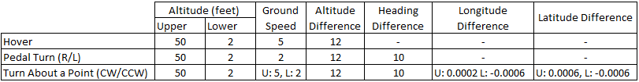

Table . Hover maneuver parameters

The parameters listed in Table 2 are optimized to this datasets. Initial values are fine tuned to find the best accuracy through a “brute force” method. The model is run on the dataset and data points that fell inside or outside the logged maneuver were inspected for trends. This results in a manual decision tree model.

### Predictions

The model results in the accuracy displayed in Table 3. Accuracy is determined from the logged value of the pilot to the predicted value of the model. The model returns an accuracy of approximately 90 percent for Hover, and low to mid 90s for hover maneuvers across multiple datasets.

|  |  |  |  |
| --- | --- | --- | --- |
| **Maneuver** | **23-Jun** | **30-Jun** | **7-Jul** |
| Hover | 0.78 | 0.9 | 0.9 |
| Right Turn | 0.96 | 0.98 | 0.92 |
| Left Turn | 0.89 | 0.97 | 0.95 |
| TABP CW | - | 0.91 | 0.93 |
| TABP CCW | - | 0.95 | 0.95 |

Table . Physics based model accuracy

To understand the accuracy results, several visualizations are inspected. Plotting the logged and predicted values with the absolute altitude, as seen in Figure 12, the logged and predicted values appear when altitude remains relatively constant. This is expected from the definition of a hover. Looking at the Right Turn maneuver we see that a Right Pedal Turn is conducted at the same time value as the hover and when compared to ground speed, ground speed is very low. During a pedal turn, the aircraft is rotating about a central axis, resulting in very little ground speed.

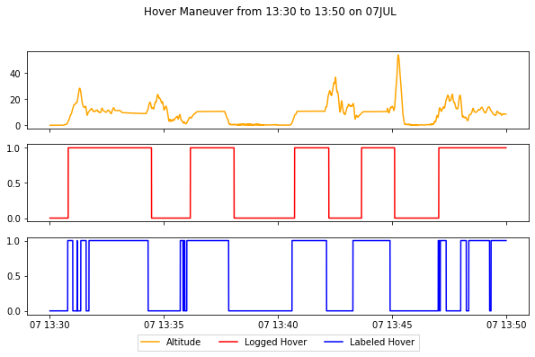 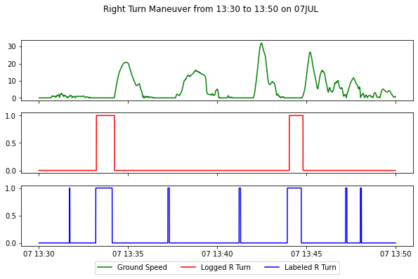

Figure . Hover predictions compared to logged time block

To further assess the output of the model, the confusion matrix is displayed in Figure 13. For the Hover the model predicts a No Hover during a Hover about 2.5 times more often than a Hover during a No Hover. Based off the flight sequence for this flight we would expect this. This can be due to pilot error, wind gusts, or several other factors that the helicopter deviated from Hover parameters. For the right turn the opposite is true. A right pedal turn is used during several maneuvers in takeoff and repositioning. But the false positive and false negative values are much closer than the Hover Maneuver.

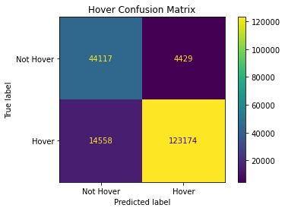 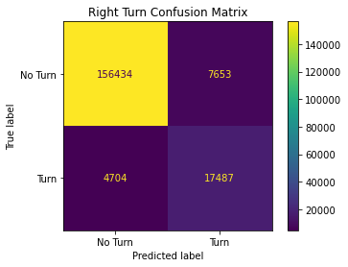

Figure . Hover and right turn confusion matrices

### Limitations

This approach does have several limitations. The model is reliant on user defined parameters that are optimized through brute force. By nature, some hidden relationships between predictors will not show as it uses less than 10% of the available predictors in the original dataset. Definitions of maneuvers are intentionally vague to ensure the ability of the instructor pilot to determine a safe maneuver. As such, the parameters used in the model are subjective. Human error is another factor in the dataset. A pilot may log that they are executing a hover but may exceed the parameters during the maneuver without annotating it. Many of the maneuvers are similar to other maneuvers. The model is not able to delineate a hover box from a hover taxi or a sliding taxi, as they are essentially the same maneuver just in a sequence. The length of the sequence can change each time the maneuver is conducted. Therefore, a rolling window to check for a sequence of changes would overfit to a particular instance of the maneuver.

## Machine Learning

The second model attempted uses a machine learning model approach. To model the machine learning-based method in detecting whether the helicopter is in a hover profile or not, a sequential approach, which consists of a machine learning model and then a simple data analysis method, was proposed and is depicted in Figure 14. The machine learning-based model starts with labeling the raw dataset to have labeled data for training. With help from subject matter experts and test standards, the parameters of interest were determined to feed into the model training process. The machine learning model that yields the best result in testing and validation was picked as a final machine learning model. The trained model was used to generate the preliminary results of predicting whether the helicopter is hovering or not hovering. The team then applied a twenty-second moving average to generate a mean average value. To be conservative about the process, the team used an average mean value of 0.6 as a threshold to decide whether a predicted value at a particular time is a good predicted result for a hovering data point.

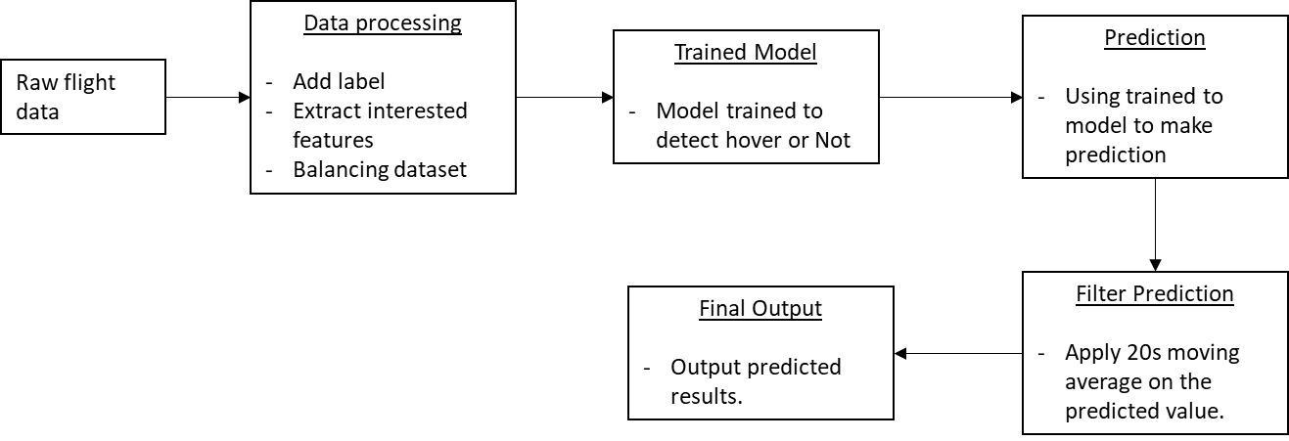

Figure . Machine learning model flow chart

### Data Processing

The raw data provided to us represents multiple flight simulations collected by the Federal Aviation Administration. Since the raw dataset provided does not contain labeled data, the team had to manually label these based on the handwritten logs provided by the FAA. After labeling the dataset, the team performed several features engineering calculations to extract the features of interest and balance the labeled dataset.

For features engineering, the data points were grouped from 0.02 seconds into 1 second. The data needed this grouping and consolidation because in the original 0.02 seconds recorded, the data points do not change a lot, and, as a result are redundant, adding a lot of processing time and consuming more resources.

For balancing the labeled dataset, the datasets contain half of the data points marked as hover and half marked as not hover. All the data points are randomly selected to help ensure the machine learning model captures all data patterns and relationships between features.

After this, the dataset is split into 70% for the training set and 30% for the test set. For validation purposes, the test dataset is from another flight simulation, which the machine learning model had not been trained or used on previously. By doing this, we can ensure that the model was not overfitting on the training dataset and that there is no bias introduced. The validation dataset goes through the data processing step to ensure the data structure is the same before being fed into the prediction machine learning model.

### Train the Model

After the data processing step, the data is fed into the training model step. For the training model step, two different machine learning models and one deep learning method were explored. These machine learning models and the deep learning method explored in the subsequent section were picked because of their well-known good performance in a binary classification problem. These models will be introduced briefly to discuss what model yielded the best accuracy in the training and validation phase.

#### Support Vector Machine Classification Model (SVM)

Support Vector Machine classification (SVM) is a linear model for classification and regression problems. The algorithm creates a line or hyperplane that separates the data into classes. The data are generalized with the support vector, and the patterns are revealed based on the hyperplane created by the algorithm. Since there is a high correlation between features of interest, as we see from the above physics-based model, between when the helicopter is in a hover or not in a hover, this method provided us with a very high accuracy from the start without any hyperparameter tuning necessary.

#### Extreme Gradient Boost Model

Extreme Gradient Boost is a random forest method or an ensemble method that uses boosting to help improve performance. Ensembles are constructed from decision tree models. These decision trees are added one at a time to the ensemble and fit to correct the prediction errors made by the previous models. The model is fit based on the loss function and a gradient descent optimization algorithm. The technique implemented in this model is much like neural networks, where the loss gradient is minimized as the model is fit. The python package that was used to implement this model is called XGBoost. It is an open-source package designed to be computationally efficient and produce a high efficiency for the model performance.

To implement this model, there are several hyperparameters that needed to be set:

* max_depth: Since it is a decision tree method, we need to set a maximum depth for the tree. This controls over-fitting of the model. The more depth of the tree, the more the model learns relations specific to the particular sample, called over-fitting.
* learning_rate: This specifies a learning rate for the gradient descent to learn between each iteration. The learning rate parameter controls how fast the model will learn the patterns withing the learning rate step. A faster learning rate could help the model learn the relationship faster with a faster output but could cause the model to not reach an optimal solution.
* gamma and reg_lambda: These parameters are used to control the overfitting and handling of the regularization part of the sample within each iteration.

#### Binary Classification Deep Learning Model

Binary Classification Deep Learning Model is an artificial neural network method where the model consists of 3 fully connected hidden layers. The first layer consists of 32 nodes, the second layer consists of 64 nodes, and the final layer is an output layer. The dropout process is also implemented between each layer for the forward propagation. For the final output, the artificial neural network will classify the data point as a hover data point or not using the sigmoid function. The parameters tuned for this method are primarily changing the combination of the number of nodes in each hidden layer, the dropout rate, and the learning rate. The team observed the model training with the higher number of nodes, and the model accuracy did not improve much. As a result, the team stopped exploring this option further as the cost outweighs the benefit of the model performance.

### Prediction

Out of the three machine learning models discussed above, both support vector machine classification and the extreme gradient boost model yield around 80% accuracy on both validation sets from July 7 and July 14 files. The deep learning model produced 80% accuracy on one validation set and 50% on the other.

Table 4 lists the outputs of the model accuracy on each validation data set.



Table . Machine learning model validation set results

As the result of the trained model phased, the support vector machine classification algorithm was determined to be the best fit model to feed into the next phase filtering the prediction results. Because of the low accuracy score of the binary classification deep learning model and the time and resources that it takes to train the model, this method was opted out and not used again to test for the July 7 and the July 14 validation set.

### Filter Prediction

After the model generates a predicted value for each data point, these values are input into a moving average analytic method to filter out any erroneous predictions. An erroneous prediction value is any value with a mean of the moving average within the 20 seconds rolling window that is less than 0.6 and vice versa for the good prediction value. The rolling window time and the moving average mean value are determined by the team's optimization method. The optimization method is a looping process through a set of defined hyperparameters which consists of a rolling window time and means of a moving average to identify which combination of rolling window time and mean of moving average yields the best accuracy score. Through this filter prediction process, the team was able to increase the accuracy of the classification up to 95% when compared to the handwritten flight log file.

## LSTM Model (Deep Learning & Artificial Neural Networks)

### LSTM & Use-cases

The “Long Short-Term Memory (LSTM)” model is a Recurrent Neural Networks (RNN) that maintains memory of input data and enables analyzing sequences in data in addition to single data points. Below are popular use-cases of LSTM -

* Identify human activity based on wearable devices sensor data
* Identify errors in a particular human activity, like a fitness workout
* Home-security sensor data to predict "Home/Away"

Figure 15 shows one of the use-cases as a reference where human activity data is analyzed through a wearable device on the wrist of a subject’s arm.

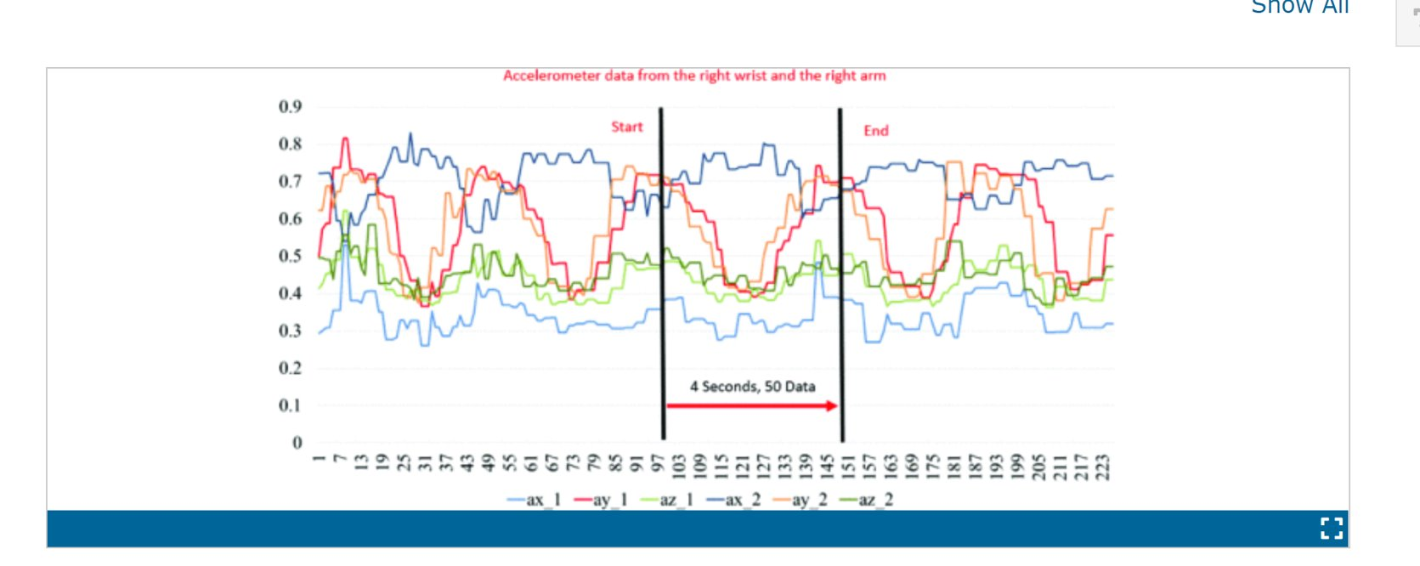

Figure . Human activity recognition based on accelerometer [16]

For a rotorcraft, a stage of a flight operation can be regular operations or specific maneuvers. Maneuvers can be considered sequences of data points in a fixed order, making the LSTM model an ideal fit for analyzing specific maneuvers. For the current problem, the data is labelled as “Hover” and “Not-hover”, and LSTM is used to test whether sequences in data points can be correctly predicted.

### Data Transformations

The flight recorder data was analyzed using the below transformations

1. Each data point was labeled “Hover” and “No-Hover”. LSTM has capabilities to handle more than one maneuver, and labeling can be extended to “Hover”, “Regular Operations”, “Left Turn”, “Right Turn” and “Box Hover”
2. Sequences for each operation were then separated from each other in a separate array. The test data consisted of 46 sequences, out of which 16 were “Hover” maneuvers
3. Each sequence was limited to a configurable number of x data points, with the value of x optimized to 500 data points.
4. The test data was converted to a single NumPy Array containing nested Arrays for each sequence
5. The target consisted of a simple NumPy Array consisting of a labeled sequence
6. The index of each sequence in the target variable correlated to the index of the sequence of data points for each maneuver
7. The data & target were split into training and testing

### Training, Testing & Validations

The input was analyzed using TensorFlow’s Sequential function. “Epochs” is a hyperparameter that indicates the number of “iterations” required to train the dataset. Each iteration is one pass forward and back against a particular statistical function. Several experiments were conducted to find the right number of epochs and data points per sequence. The chart below shows the accuracy of the model based on the value of hyper-parameters. This approach was found to be beneficial for tuning the hyper parameters of “sequence length” and “epochs”



Figure . Epochs = 10, Sequence length = 500

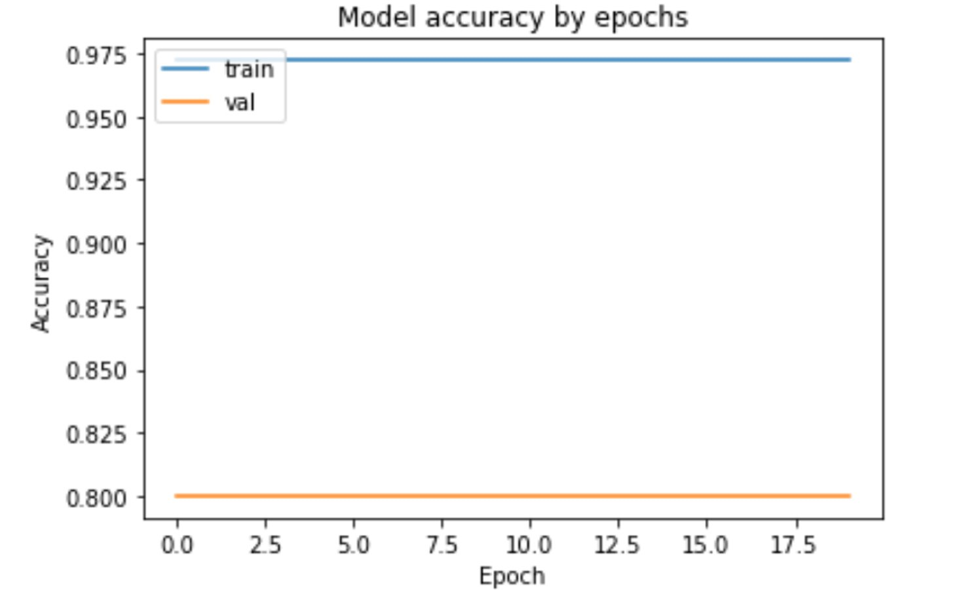

Figure . Epochs = 20, Sequence length = 1000

### Results

The validation yielded an accuracy of 90% where epochs were set to 10, test data size was 46, 15 hover maneuvers were present in the test data and each data point contained a sequence of 500 data points. This result can be improved upon by training with additional sequences of test data and further classifying the generic category of “No-hover” into specific categories of “Regular Operations”, “Left Turn”, “Right Turn” and “Box Hover”. Each maneuver gets predicted if the probability of match is greater than 0.5. The probability of match can also be used to indicate the score of a particular maneuver assuming the training data is a perfect 10.

### Opportunities for future expansion

The current model can be improved upon by adding more maneuver iterations to the data set and labelling each maneuver correctly and more precisely for the beginning and end time. Dataset from several flight simulator runs can be joined together to create a large dataset of maneuvers without altering the sequence within every maneuver. Each maneuver needs to be classified within a particular category. LSTM can then learn from every sequence and correctly classify the validation sequences in several different categories.

The LSTM model can then be applied for the below use-cases for the rotorcraft data:

1. Analyzing flight recorder data and identifying patterns to detect different maneuvers
2. Predicting a maneuver in real-time when the pilot begins performing it

# Visualization

## Data Analytics Model

The Data Analytics approach is determined as the approach most redundant to aircraft and environmental conditions. The parameters the model is based on are not specific to aircraft type. The model results in accuracies in the low 90%. As the model is heavily reliant on user-specified inputs, it is not able to learn from interactions between predictors. Figure 18 shows the results of the model performance with predicted maneuvers compared to the true value of the maneuver. The true value is obtained from the flight logs of the pilot. The model displays good predictive power of the maneuvers. It tends to over-predict turns, but generally lines up with maneuvers. Using this method, the FAA can quickly label a dataset by processing the dataset through the model. The GANT Chart offers a quick overview of the time tags associated with each maneuver, rather than manually labeling each data point from the flight logs.

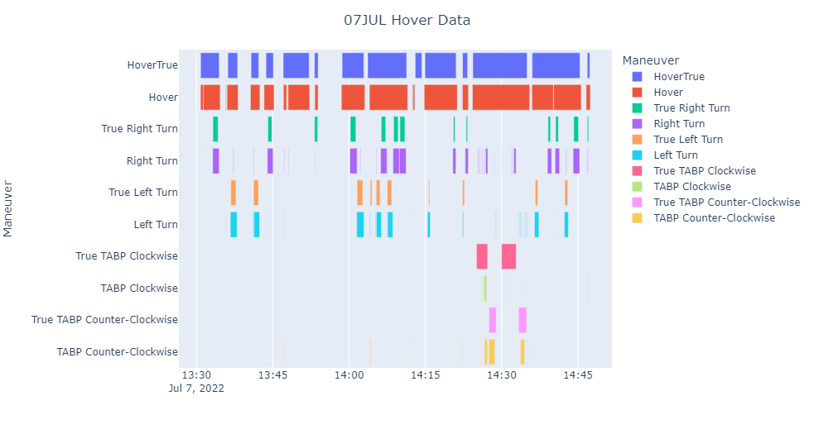

Figure . GANT Chart of 07 JULY hover maneuver data

Once the dataset is labeled, investigators can look at a number of predictors compared to maneuvers. We can subset the data and look at engine power over the course of the hover maneuver, control inputs, and altitude deviations. If the aircraft suffered a mishap at a known time or location, we can easily plot the longitude and latitude of the aircraft to show which maneuver it was conducting at the point in time and space as in Figure 19.

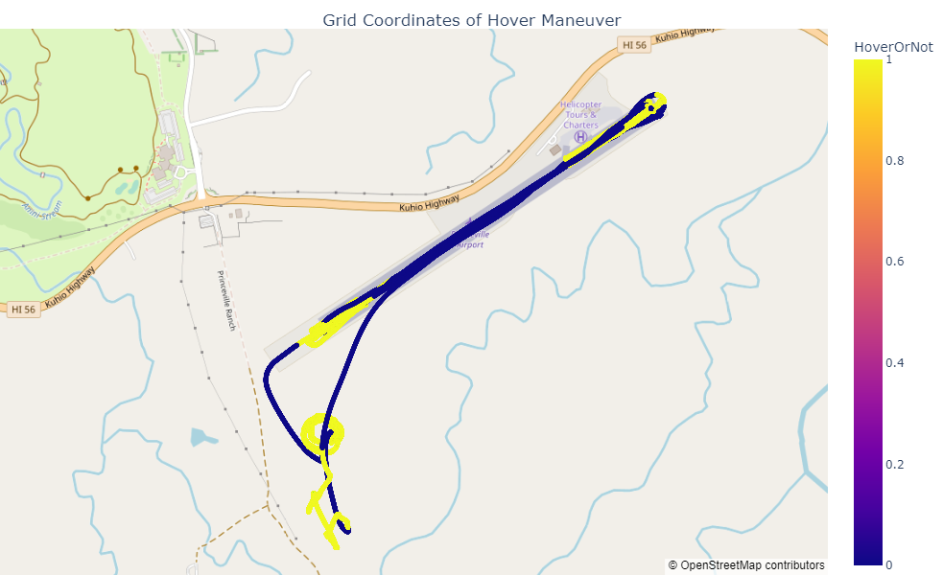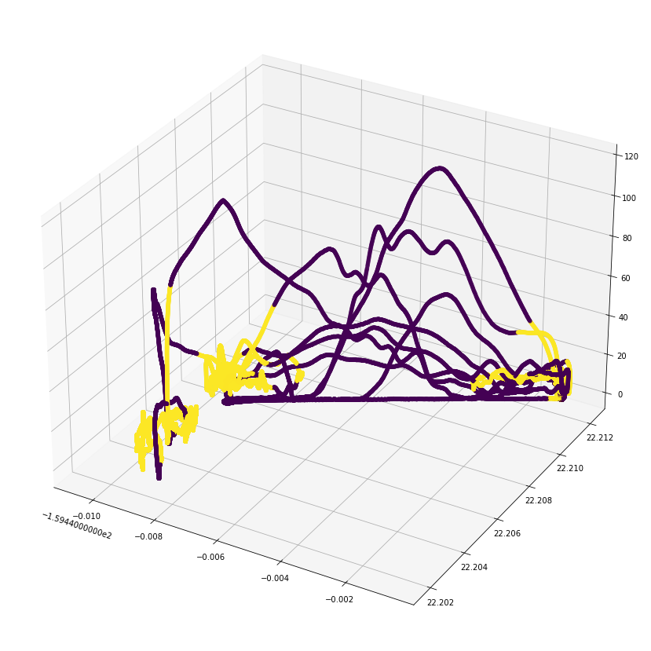

Figure . Latitude and longitude plots of hover maneuvers

Also displayed in Figure 19 is a 3d plot of the maneuver. Looking at the two plots we can see that in between maneuvers, the aircraft is gaining altitude, losing altitude and traversing from one end of the runway to another.

The model is built in Python 3 and produces three visualizations, two dataframes and outputs the original ROAR datafile labeled with binary labels for each maneuever per data point. One of the produced data frames is the full predictor set with engineered features. The second data frame lists start and end times for each maneuver. The visualizations allow the reader to see what maneuvers are happining along the timeline of the flight. The latitude and longitude plot allow the reader to see the maneuvers along the flight path.

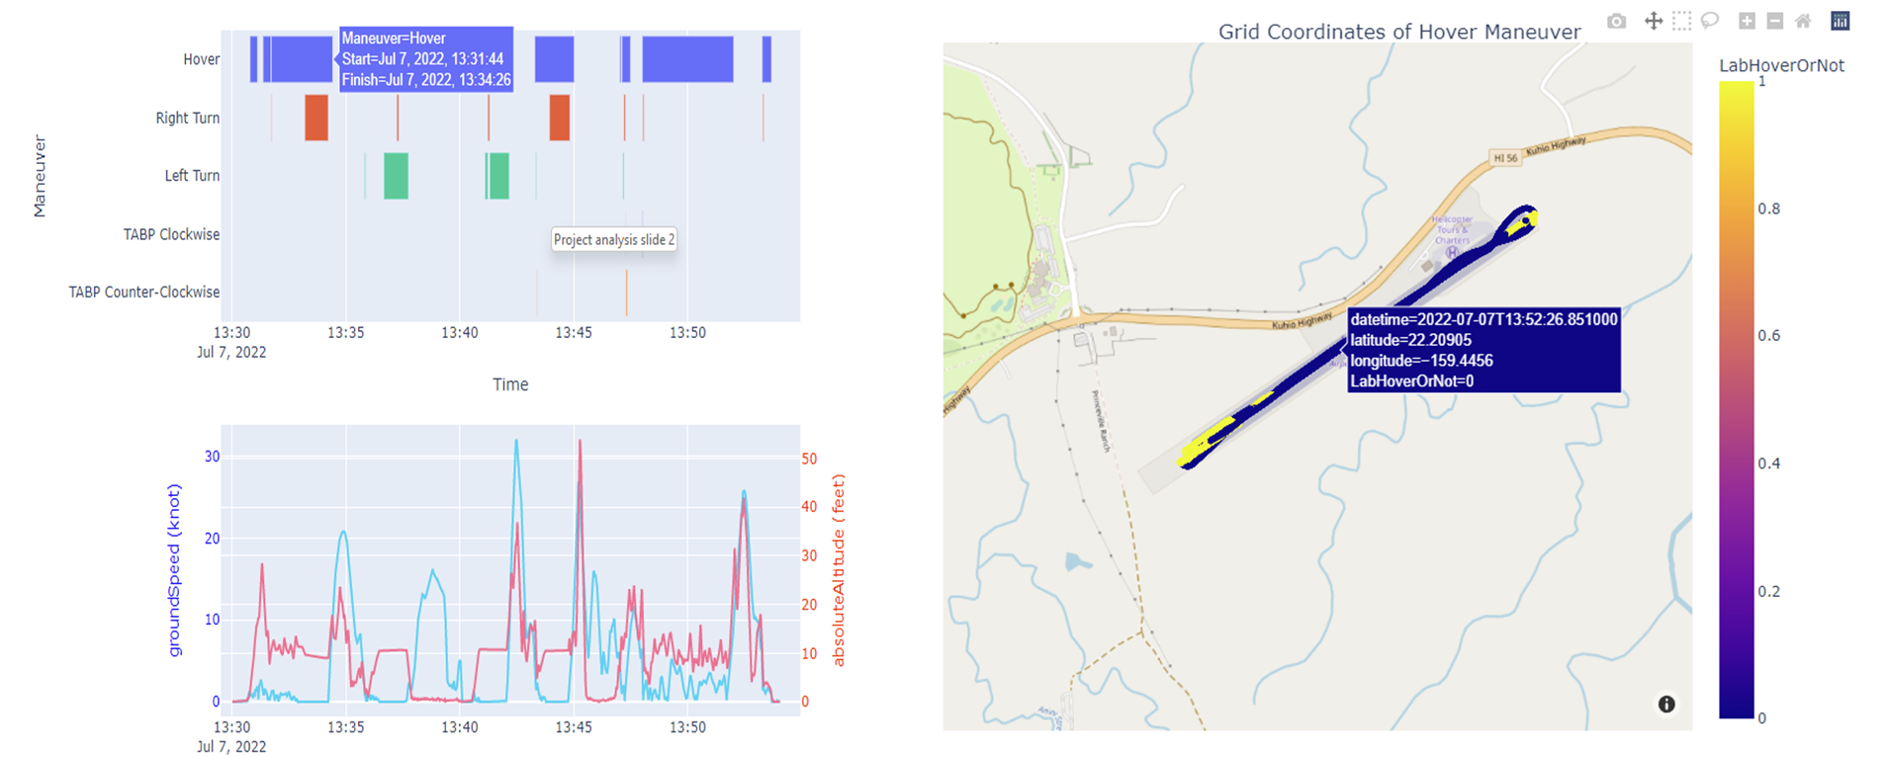

Figure . Physics hover model visualizations

## Machine Learning Model Results

The team used a GANT chart to visualize the prediction result from the machine learning model. With the GANT chart, the activities or tasks, whether the helicopter is hovering or not hovering, and the predicted value from the model, can be easily displayed against time. With the model prediction accuracy of 94%, we can see from the chart below that the predicted hover and not hover data points overlap with the value from the flight log. Hence from this visualization, the FAA personnel can efficiently track the predicted activity of the helicopter over time.

Figure 21 and Figure 22 show the two figures comparing the hover maneuver predictions before and after applying moving average on the prediction results.

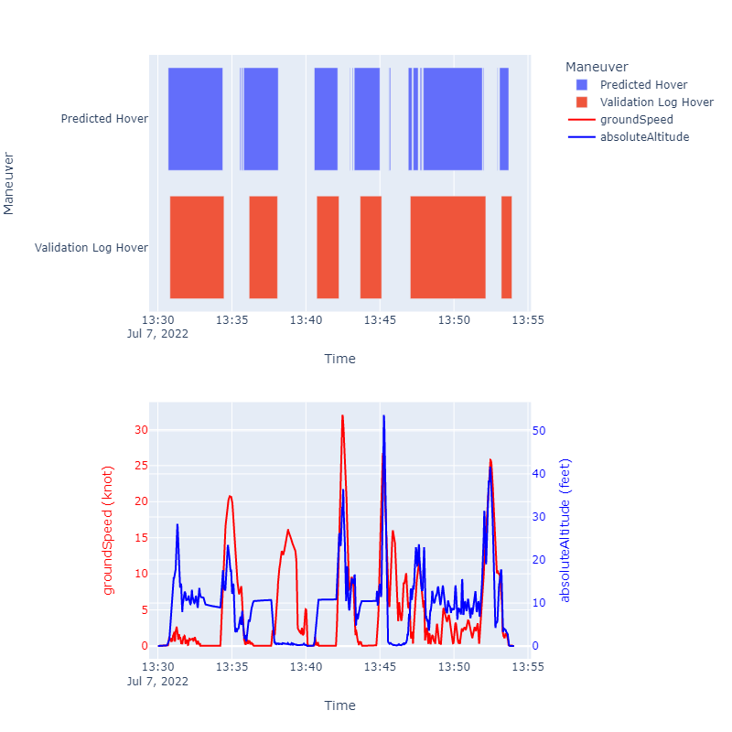

Figure . Machine learning model results before prediction filtering

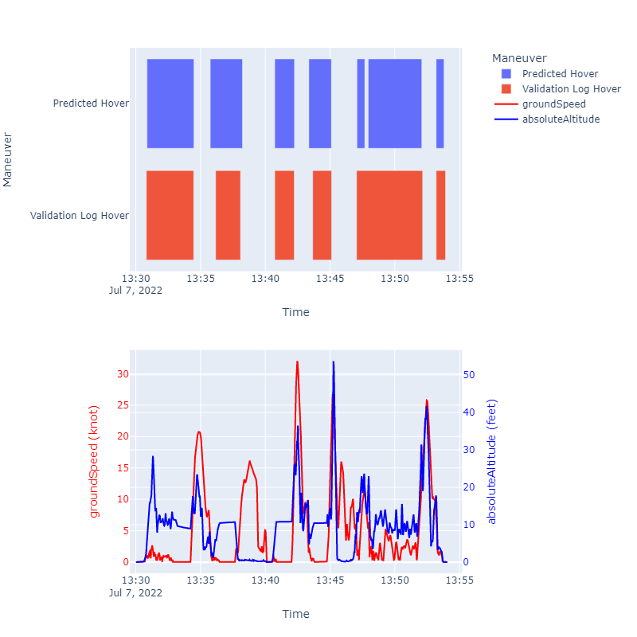

Figure . Machine learning model results after prediction filtering

Comparing the result for predicted hover from Figure 21 and Figure 22, we can see many time segments that the machine learning model predicted a hover. However, that time segment is not significant enough as it requires an action to be at least 15 seconds to consider it a proper hover maneuver. With that in mind, after applying the moving average to filter out any erroneous prediction, the model's accuracy increased significantly, as shown in Figure 22. Most erroneous predictions with a lighter blue in Figure 21 have been eliminated from Figure 22. Furthermore, the line chart on the bottom of the above figures that show the ground speed and the absolute altitude of the helicopter throughout the flight also confirms our hover prediction against the true hover from the log. The ground speed usually falls under 10 knots, and the absolute altitude also aligns with the physics-based model, where the range is between 5 to 10 feet above ground level.

## LSTM Results

The Pyplot below indicates actual and predicted hover maneuvers. The misclassified and correctly classified maneuvers can be correlated using heatmaps & histograms to investigate them further. The existence of blue sections in the visualization below indicates incorrect predictions by the LSTM model

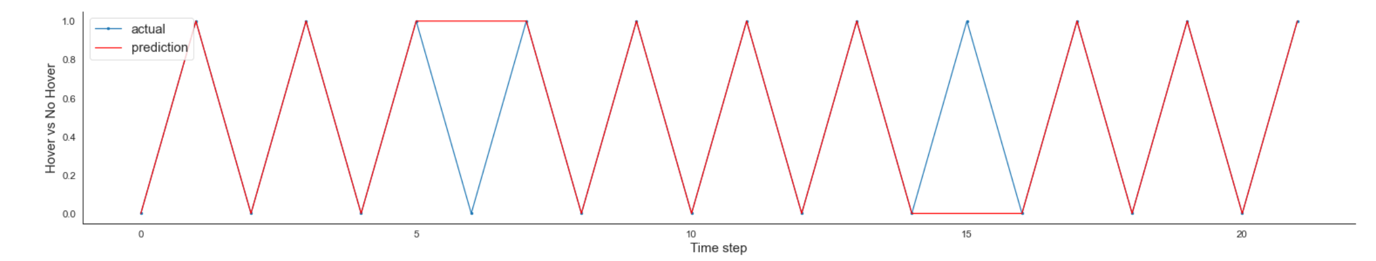

Figure . PyPlot of actual and predicted maneuvers in validation data

### Not in Hover & Correctly predicted

A “Not in Hover” might include another maneuver being performed or other random sequence of events which will generate variances in data as indicated below. Also observe the positive correlation in the heat-map indicating the pilot was actively performing activities usually not performed in a Hover.

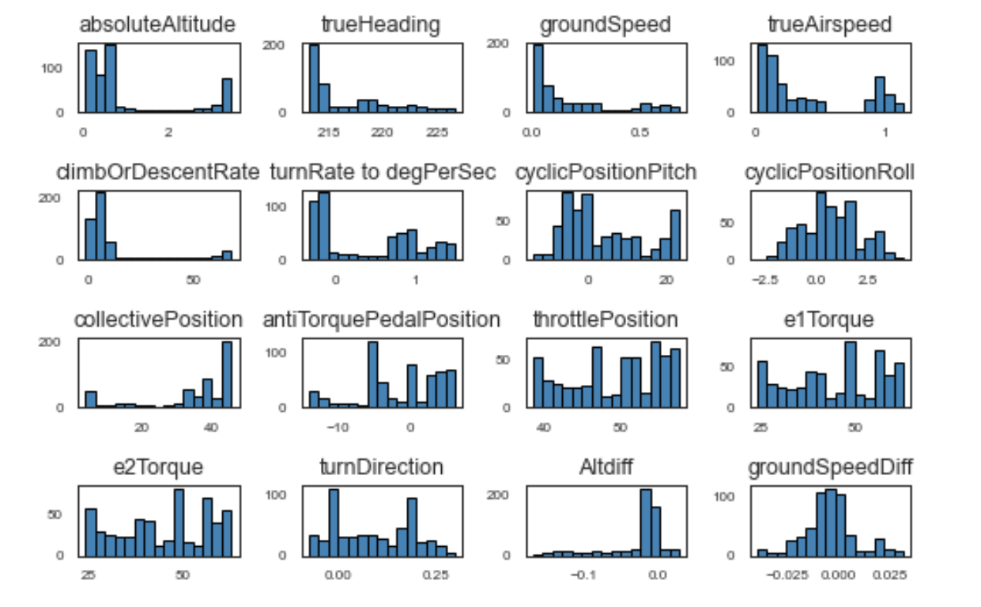

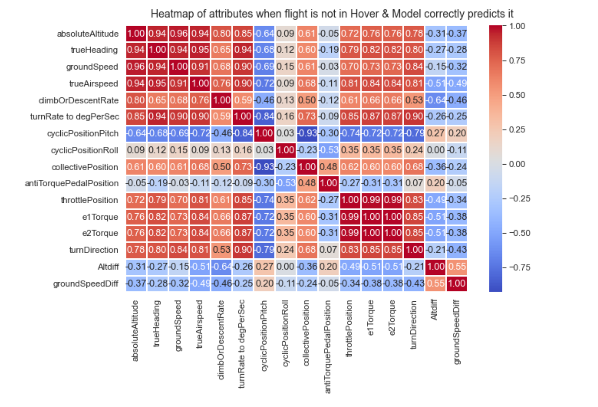

Figure . Histogram and heatmap for correctly predicted "Not in Hover" results datapoint - 2

### Hover & correctly predicted

As expected, hover maneuvers have limited variance for a combination of altitude difference, true heading, ground speed and turn direction difference. Observe the heatmap where no significant relationships exist between parameters.

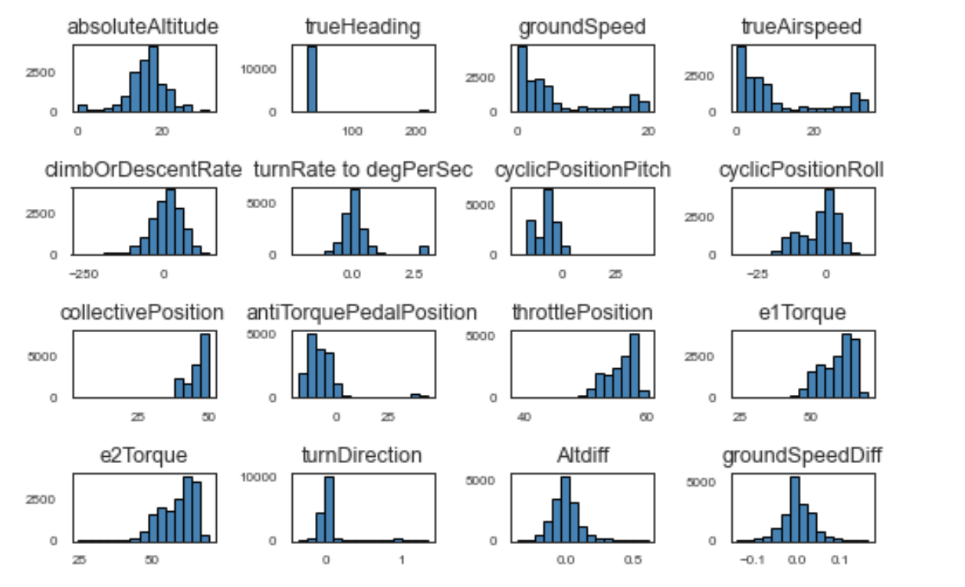

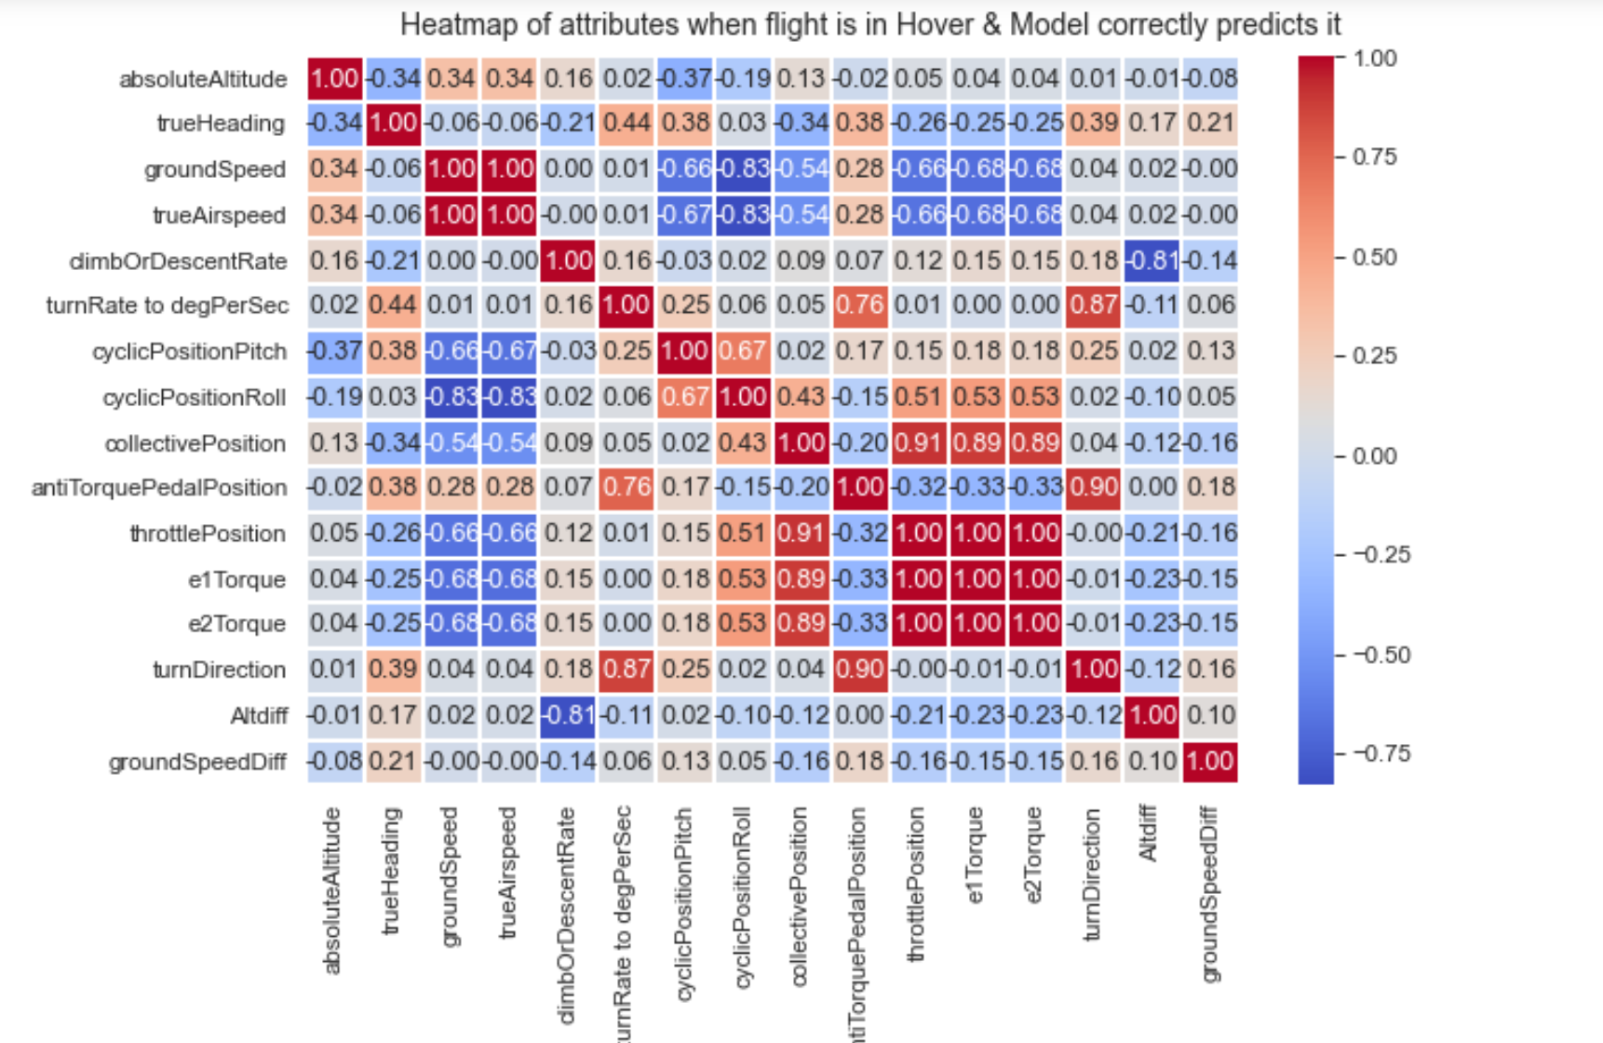

Figure . Histogram and heatmap for correctly predicted "Hover" results datapoint - 1

### Not in Hover not predicted as expected

The below data point was predicted incorrectly by the LSTM model as a Hover maneuver. The chart below shows limited variance in the data, which is a definition that the model has established for the hover maneuver. Altitude difference, true heading, ground speed and turn direction difference have no variance at all indicating that the data-point might be mislabeled in the manual notes.

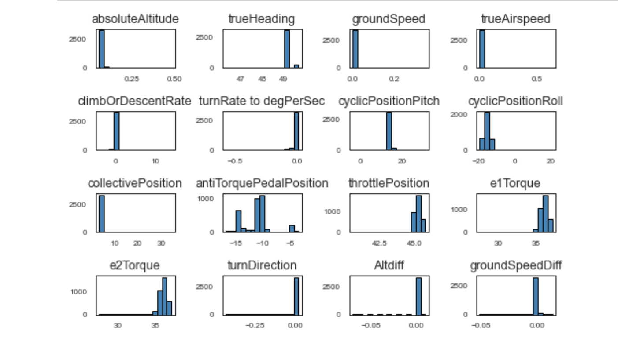

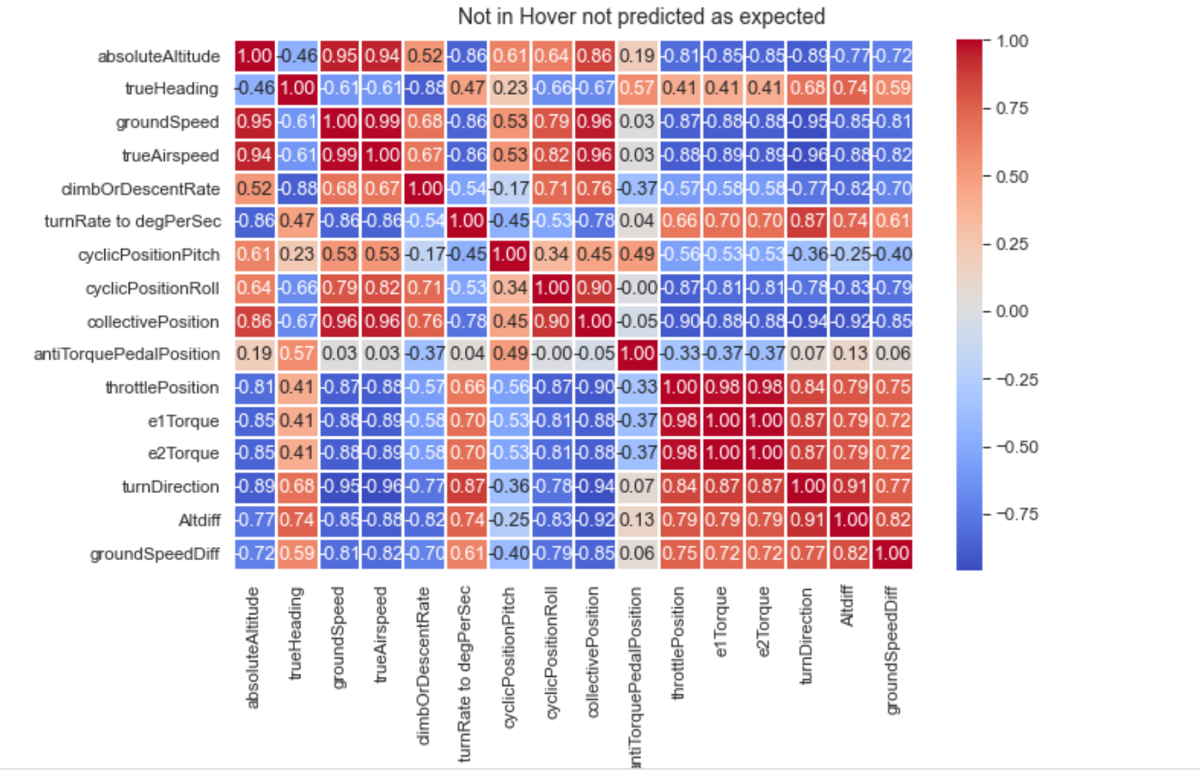

Figure . Histogram and heatmap for "Not in Hover" not predicted datapoint - 6

### Hover not predicted as expected

The charts below indicate the existence of significant variance in the parameters that define the hover maneuver and hence the datapoint was incorrectly predicted as the rotorcraft being “Not in Hover”.

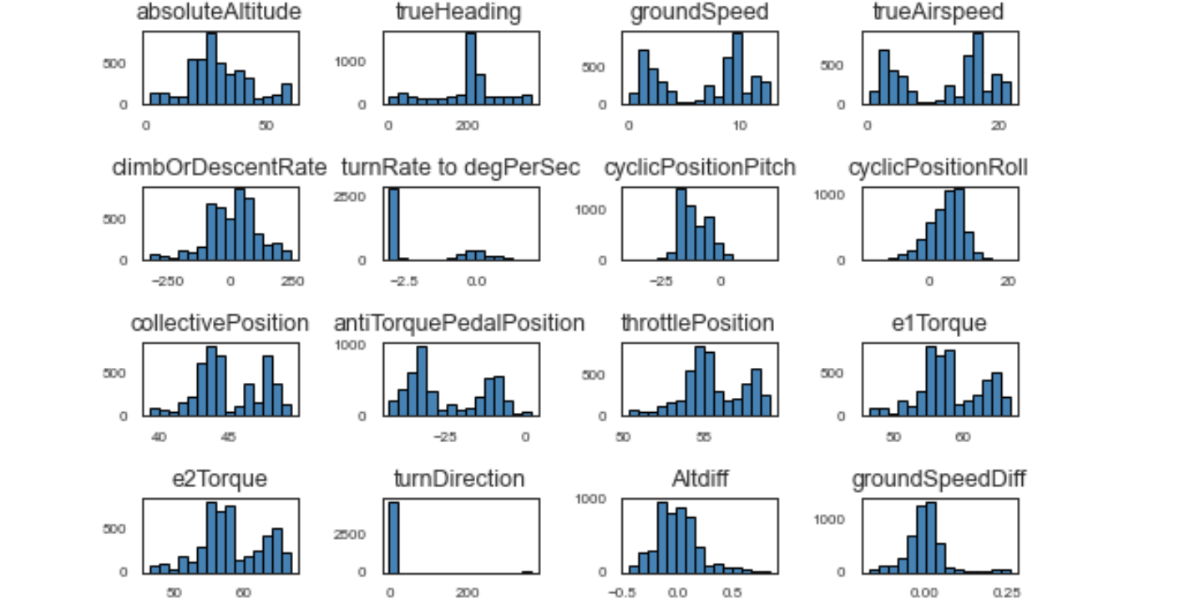

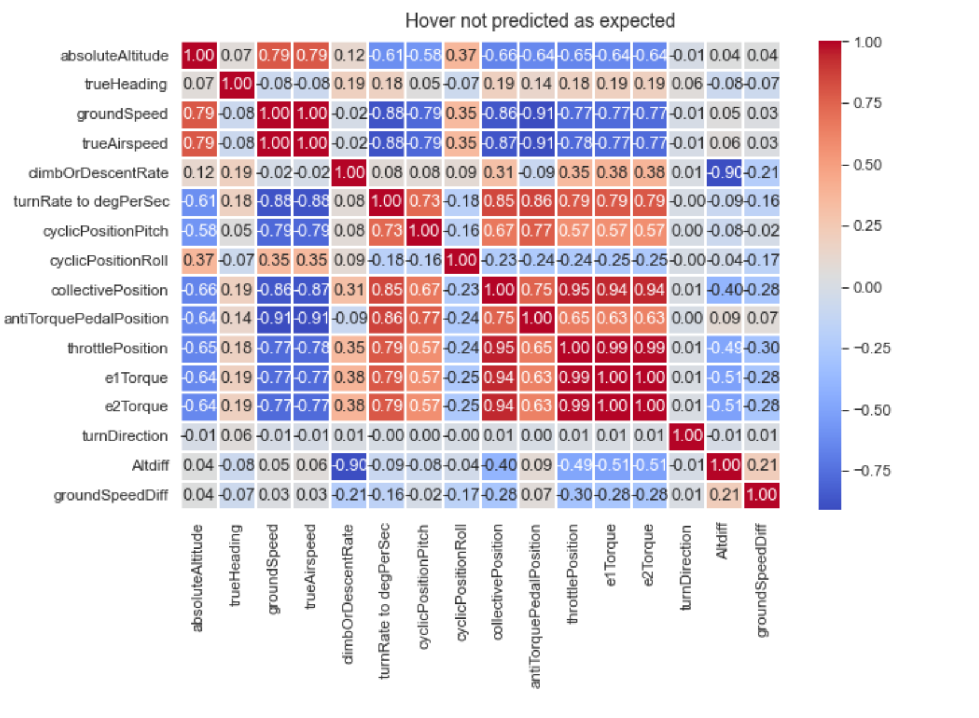

Figure . Histogram and heatmap for "Hover" not predicted as expected datapoint - 15

# Findings

As seen in Goblets approach to fixed wing general aviation and Chin’s filtering approach to rotorcraft phase of flight, filtering for physical parameters can reasonably identify Hover Maneuvers with an accuracy around 90% [11] [7]. The physics-based model utilizes parameters that will not change given an aircraft type. The model does rely on a physical definition of a hover maneuver. These definitions and parameters are not strictly defined in manuals. The advantage of a vague definition allows instructor pilots to determine if a candidate pilot is achieving the intent of the maneuver. The disadvantage comes as researchers attempt to classify maneuvers for further study. It is difficult to objectively grade a vague standard.

The machine learning model, specifically the Support Vector Machine (SVM), learning model can identify more relationships between predictors in hover prediction compared to the physics-based model hence increasing the hover prediction accuracy. As pointed out from the physics-based model, there is a high correlation between predictors and the outcome variable hover or not hover. Therefore, we can randomize the training dataset without considering the sequential event and feed that into the SVM model to classify whether the helicopter is hovering or not hovering. On the other hand, the Support Vector Machine (SVM) did not perform well in predicting the hover maneuvers, such as pedal left turns, right turns, and hovering over a point. Due to the nature of these activities relying heavily upon sequential events, the following helicopter activity can be predicted based on the previous activity. Hence, to better predict these activities using a machine learning model, it would require a different approach that would take into consideration the sequential events to make a prediction, such as LSTM or RNN deep learning models. Furthermore, the training set will require a lot more data iterations to make this happen.

The benefits of using sequential data to analyze maneuvers defined in the above section indicates that the LSTM Model has the capability predict different maneuvers if sequence of flight recorder datapoints is passed as inputs to the model and a match is found. Additionally, the probability of match to a particular maneuver indicates the pilots score when the maneuver is performed assuming the model is trained on a perfect maneuver.

Table 5 shows the accuracy of predicted and logged hover maneuvers across the three approaches.

|  |  |  |  |
| --- | --- | --- | --- |
| **Maneuver** | **Physics Model** | **SVM** | **LSTM** |
| Hover | 0.92 | 0.95 | 0.90 |

Table . Model accuracy for hover

# Summary

This paper looks at three different techniques for categorizing flight recording data for hover maneuvers. The physics-based model offers a high degree of accuracy in predicting a range of maneuvers. It requires the least computational resources and quickly returns a labeled dataset. This method is also the most redundant to helicopter type and environmental conditions. However, the model loses accuracy when applied to maneuvers that involve sequences. A Hover Box essentially is the same maneuver as a Hover Taxi or Air Taxi, the sequence of four legs with no heading changes differentiates it from a taxi. The model in its current form just predicts this as a hover. The Support Vector Machine offers the highest accuracy on the hover maneuver. However, it requires a large, labeled dataset to train on. The model learns relationships between parameters. This means that the model needs to train on each model of helicopter. The LSTM model resulted in the lowest accuracy, but still above 90%. The ability to learn sequences of maneuvers and compare it to a “perfect hover”, the training set builds in a method to score the maneuver as well. It, like the Support Vector Machine, requires a large, labeled dataset to train on. The LSTM may show its power in predicting a wider variety of “Hovers” as it is trained on an increasingly larger labeled dataset.

Previous Research conducted on this topic focused on phase of flight identification. The challenges increase as we move to classify individual maneuvers in rotorcraft that follow a less specific and more varied flight plan than general aviation [12]. A commercial airliner will only be under 10,000 feet at the beginning and end of a flight. A helicopter will hover at 50 feet during takeoff, landing, showing a tour group a view of the Grand Canyon, or picking up water in a bucket to dump on a forest fire. Even with these differences, analysis of flight data monitoring recordings allows us to identify specific maneuvers during flights. Engineers can then study in greater detail what went wrong during an accident investigation, instructor pilots can then objectively score their pilot candidates, and we can ultimately increase the safety of rotorcraft operations.

# Future Work

This paper describes 3 different mechanisms for analyzing rotorcraft maneuvers – the physics-based approach, machine learning using individual data points, and deep learning using a sequence of data. As with any data analytics solution, using a combination of different techniques is always beneficial to predict the right outcomes.

The current machine & deep-learning models are tuned for “Hover” maneuvers. To train additional maneuvers, these algorithms require the existence of at least 35-40 different sequences for every maneuver. This data can be used from real-life rotorcraft pilot training or can be mined using simulators like the approach followed in this paper.

The risk of using mined simulator data may introduce bias due to the non-existence of naturally occurring unpredicted external environmental factors. The bias would be towards the settings of the simulated environments. One possibility is to use real-life pilot training data sets from the flight recorders of rotorcrafts. Additionally, the models can be tested across several rotorcrafts by using parameters that don’t change with different rotorcrafts. This will eliminate the requirements for this model to be trained for each different model of rotorcraft. The current model is biased towards the simulator rotorcraft types and can only perform with a high level of accuracy if used to test with the same rotorcraft types.

The LSTM model uses a combination of data points and validates whether the combination translates to a particular maneuver. The shortfall is that with an unlabeled dataset, predicting the start and the end of the maneuver is a challenging process. One possible future course of action can be to label the dataset using a physics-based approach and then use LSTM sequences to validate whether each maneuver was predicted accurately. Additionally, LSTM sequences can easily score a maneuver based on the probability of a match if the model is trained using the perfect maneuver. This functionality is helpful for scoring a pilot-performed maneuver.

Summarizing the analysis above the next steps would be –

* Gather additional data about non-Hover maneuvers and train the ML & LSTM models for those maneuvers.
* Train the models on different rotorcraft types.
* Train the models outside of simulated environments.
* Determine the start and end time for maneuvers to eliminate the need of labelling the data.

# Appendix A: Code References

All code referenced in this paper is located at: https://github.com/davyeno/rotorcraft-project.

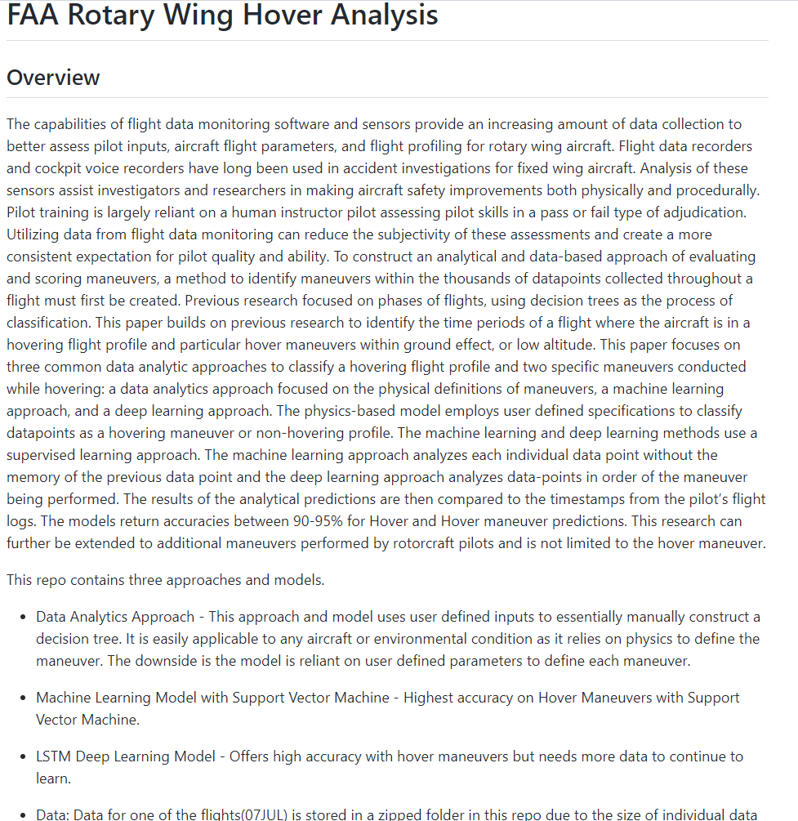

# Appendix B: Risk Section

## Sprint 1 Risks

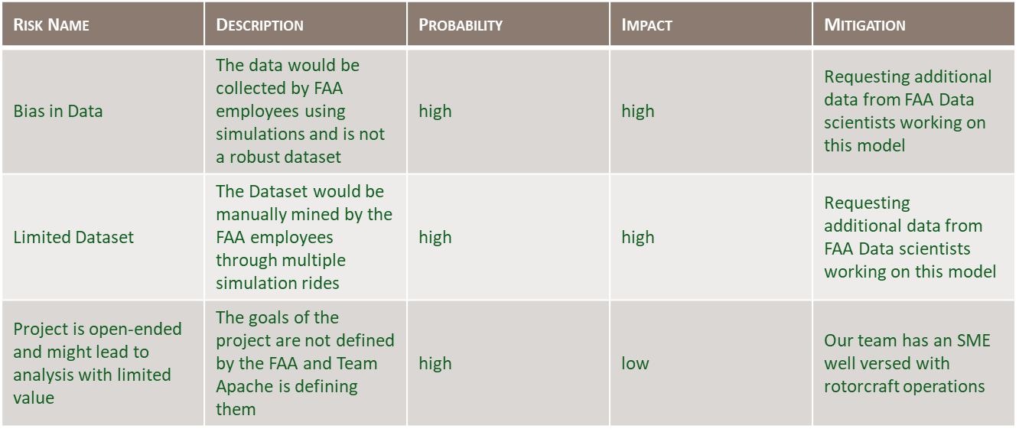

Table . Sprint 1 Risks

Though the introduction to the project that was included in the course pamphlet was descripted overall, the team got off to a slow start in identifying the specific problem space and objectives of the project. After our initial meeting with our sponsor from the FAA, things moved along a lot smoother. The FAA provided a large folder of previous research that had similar objectives or analyzed components that would be necessary for understanding the scope of our project. Though we were able to start reading background information and developing an idea of what this project would entail, we were not able to develop a specific problem space or objective until after our initial meeting with our sponsor during the second week of the sprint.

We identified the bias in the dataset and limited dataset risks early on. Because we knew that the data would be collected in a simulator, we were aware that the data would not be subject to the outside factors like a real-life aircraft, such as environmental variables and variances between specific aircraft. Additionally, we noticed that in the previous projects the data collected for labeled data was done manually and the collected data from the simulator would require a lot of data refinement through manual labeling to be able to test our analytical methods for accuracy.

Our initial meeting with the FAA was open ended and allowed a lot of creativity and interpretation for the team. This is good because it gave our team the ability to capitalize on our imaginations and use creativity to guide the project to the end state. At the same time, we were unsure if the final product would be used in the future or if it would end up on a data storage file. In the end, we were able to provide a product that the FAA is happy with, and they have plans for future use and expansion.

## Sprint 2 Risks

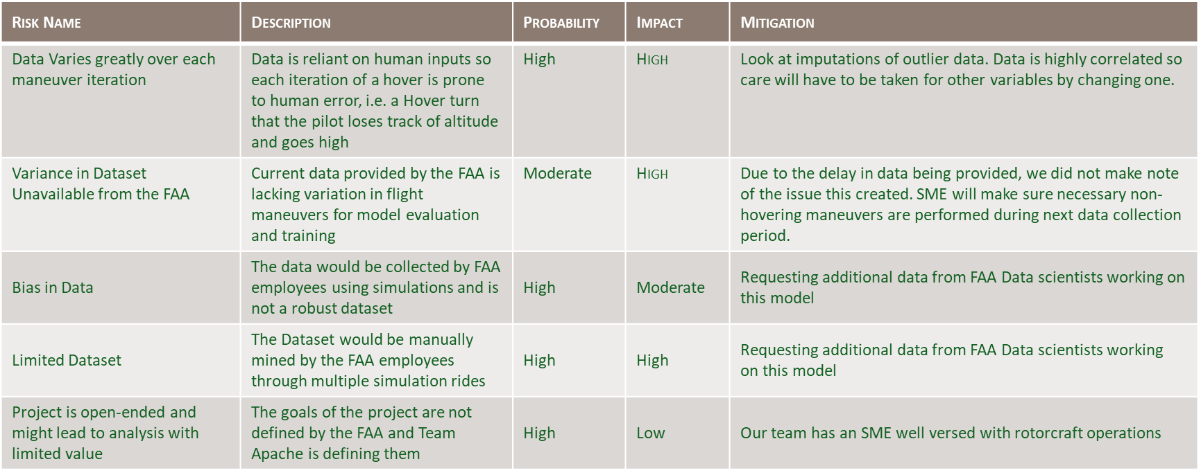

Table . Sprint 2 Risks

Data acquisition was an ongoing process throughout the project. Each week, a new set of data was created and collected from the simulator for our analysis. Because these simulator sessions to collect data happened on a weekly basis, we had time between simulator sessions to conduct analysis, assess where we could benefit from having additional data, and determine error contributors and discuss how we might be able to mitigate these errors before the next data collection.

The primary risk with Sprint 2 was the data acquisition. The data collection process had a lot of human factors, significantly contributing to the potential for errors in the datasets. For example, the simulator was being “flown” by two human pilots. Each maneuver inherently was different from the last one. Additionally, the data labeling was hand recorded by an observer for the start and end times of each maneuver. Because the simulator collected a new observation on average every 0.02, the manually labeled data could not possibly have the same level of precision. The team needed to discover new ways to implement the manually labeled information into the dataset without inducing additional error by creating a lead or lag time for the maneuvers’ time stamps.

## Sprint 3 Risks



Table . Sprint 3 Risks

The risks associated with Sprint 3 are very similar to those in Sprint 2. The human errors induced in the data collection process were also evident in the analysis and creation or algorithms. The team developed three approaches to modeling the maneuvers: physics based, machine learning, and long short-term memory. The physics based model produced results very quickly using the knowledge of physics and aerodynamics necessary for a helicopter to hover, maneuver, and fly in general. The machine learning and LSTM models also produced results, but it became clear that the amount of data we could collect would not be sufficient enough for the models to reach their full potential. The data collection process was the limiting factor for our ability to move forward with these two models’ development.

## Sprint 4 Risks

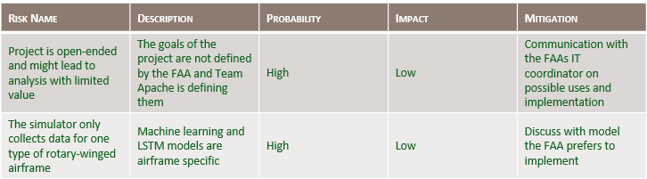

Table . Sprint 4 Risks

After creating a model, we needed to determine the best way to create a visualization that provided easy interpretation and real-life use. This required an in-depth discussion with our FAA sponsor on what current systems they have in place, how we can create a visualization for our model that could easily be integrated into their existing data models and visualizations, and what they would like depicted. By meeting with the information technology coordinator, we identified a solution to all of these risks with very little issues or changes required to our existing models or code.

As discussed with Sprint 3, the machine learning and LSTM models would require several more data collection iterations and time-consuming manual labeling of the data to fully create and implement these models. Additionally, because these two methods included all of the variables in the dataset, the models are specific to the S76 Sikorsky and any other helicopter model would require a completely different set of data collection and model development. Because of these limiting factors, the FAA determined that the physics-based model was the most time-effective method that they would choose to implement in the future.

## Sprint 5 Risks

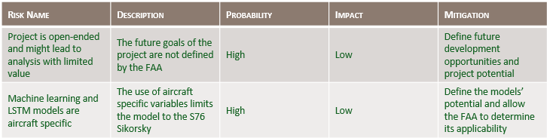

Table . Sprint 5 Risks

Our project was limited to the identification of a hovering versus non-hovering profile and two specific hovering maneuvers. The development of our identification method could lead to endless other maneuvers eventually being able to be identified using similar specifications with further research. By presenting the capabilities of our models, we are able to show the FAA the potential for maneuver identification and eventual objective grading processes using analytics for pilot evaluation and qualification. Hopefully, this will lead to future development and use for time-labeling flights using analytics instead of handwritten notes.

The machine learning and LSTM models produced results with high prediction accuracy. The models are valid and useable, but they are specific to the S76 Sikorsky helicopter that is simulated in our datasets. By sharing these models with the FAA and showing them the potential these two models have, we are leaving the decision to continue development of these methods up to the FAA to determine the cost-benefits of the time required to collect data on other helicopter models to develop similar models.

# Appendix C: Agile Development

## Scrum Methodology

Figure . Scrum Methodology Timeline

Adopting the scrum methodology, in theory, was quite simple. The job assignments and associated responsibilities and duties made sense in how the positions are meant to work together to accomplish the project’s goal. Implementing the methodology into practice was more of a challenge at the start. Since none of the team members have worked on a project using the scrum method, we needed to revisit the weekly tasks regularly to ensure we were touching on everything that was due each week. Over time, the repetitive nature of the scrum methodology became more routine and manageable without needing to remind other members to complete their tasks. As with adopting any new method, this progression of implementation was expected. We learned that by taking the time to regularly revisit the scrum methodology and its associated tasks for each sprint helped us along the way to make the necessary progress each week to keep up with the project timeline.

Similarly, YouTrack and its implementation also needed to be revisited quite often. Though all team members were used to having a checklist of items to contribute to the group, using YouTrack as a method of tracking and to create a process of checks and balances was a new concept. Though we did use YouTrack to assign task to each team member throughout the course of the project, we never reached full efficiency and maximum use of the tool. Because of the consistent meeting times throughout the week, it became almost unnecessary after the tasks were officially assigned to each member. The YouTrack tool certainly has added value in cases where the team does not meet regularly, but since we were meeting at minimum two times a week, typically three times a week, it seemed almost redundant and was often forgotten until the end of the sprint as a final follow-up check that every tasks had been completed.

## Sprint 1 Analysis

The team immediately dug into the large number of reading materials that were provided by our sponsors from the FAA to ensure we understood the methods that were used in past projects, how we could take away lessons learned and move forward in creating a product that would be useful. We started with writing the background and previous research sections. After our initial meeting with our sponsor on week two, we were able to develop our problem space, user stories, and sample scenarios. By starting with these sections, we could start to form concepts for the solution space and methods we envisioned might work to accomplish the project’s goal.

Overall, Sprint 1 was an evolving section throughout the project because it needed to be updated and further developed as our ideas were put into practice. This had its benefits and its challenges. We benefited because we were consistently circling back to our problem space, ensuring we were staying on task and remaining within the scope of our sponsor’s goals. This challenged us because, with anything, doing routine things routinely is not always easy and we had to make sure it did not become a matter of convenience, and remained a priority.

Because one of the team members is a helicopter pilot, we were able to identify possible user stories and sample scenarios with ease. This provided a very clear picture for how the project’s implementation would benefit the aviation community and how our project could be expanded in the future to involve more scenarios and solutions that our project on its own.

## Sprint 2 Analysis

This Sprint, like Sprint 1, was also an ongoing process through the entire project. We collected a new dataset in the simulator every Thursday. We received the new dataset every Friday afternoon and were able to assess the data and contributing error before the next data collection period the following week.

The simulator data is collected by an internal system, so the data had no missing or null values. We did need to conduct data pre-processing and conditioning after each data collection iteration before moving into analysis. To develop a labeled data set for accuracy comparisons with our model, we needed to manually add the labels to each dataset based on the handwritten flight logs from each simulator period. Also, because of the high frequency of the automated data recording compared to the handwritten logs, we needed to assess an appropriate frequency for calculating the change in the simulator’s flight profile to ensure we were not inducing further error within our analysis.

After a few weeks of data collection, we discovered that we needed non-hovering maneuvers within the dataset to create a variety of flight profiles within the dataset. Because our initial collections were all hovering maneuvers, there were very few observations that were identified as “not hover”, limiting our ability to assess our model. After this discovery, we ensured the flight profile was broken up by flying other flight profiles, such as a traffic pattern or a simulated takeoff and landing, between hovering maneuvers.

## Sprint 3 Analysis

Between each simulator period, the team worked hard to refine their analytical processes to create the most accurate prediction models possible. Through this, we were able to discover potential ways to reduce the human-induced error throughout the collection process. After the first two simulator periods, we discovered that collecting data primarily or solely in a hovering profile did not create enough flight profile variation to assess if our hover or not hover predictions were effective. For the following simulator sessions, we ensured the hovering maneuvers were split up by a non-hovering profile to assist with this portion of the analytical process and assessment. Also, the more data provided for the machine learning and LSTM models, the better the team was able to refine their models to improve accuracy. Unfortunately, because of the slow process of data collection, this development was not able to come to full fruition. The physics-based model was the most time conservative and presents the ability to apply the model several models of aircraft. For these reasons, the physics-based model was chosen by our sponsors at the FAA as the primary model for our project.

## Sprint 4 Analysis

After the models were developed, we met with our sponsor to discuss what they would like on the final visualization product. The FAA determined that they wanted a flight timeline marking the occurrences of a hover profile, left and right pedal turns, and clockwise and counter-clockwise turns about a point in a GANT Chart with a corresponding line graph of the aircraft’s altitude and airspeed. These visualizations were not too far from what we were creating throughout the development process and therefore required only minor refinement. We were also able to produce a map of the aircraft’s flight path using color coding to depict where the aircraft was hovering and where it was in a non-hovering profile. Overall, this sprint went very smoothly and as planned and our sponsor plans to implement our visualization outputs in their own systems.

## Sprint 5 Analysis

Our team was able to create three models with a 90% or higher prediction accuracy for a hover vs non-hover profile. Only one of these models was able to predict the two specific hovering maneuvers requested by the FAA with the limited data collection we were able to conduct through the duration of our project. Machine learning and LSTM both require a much larger number of data iterations for each maneuver to be able to create a model for further use, which was our limiting factor for being able to expand on these two models beyond the hover versus not-hover prediction.

By sharing our results, visualization, and analysis process with the FAA, we hope they will continue to develop our methods and models to identify other maneuvers required in a helicopter pilots’ evaluation and qualification flights. This project could eventually lead to a fully analytically time-labeled flight log that could assist in creating a more objective method of grading. Hopefully, this could help in creating a more consistent baseline for pilot qualification, reducing the number of fatal helicopter accidents, and keeping our aviators safe.

# References

|  |  |
| --- | --- |
| [1] | K. Moon and A. A. Yakovlev, "A Comparative Statistical Analysis of Global Trends in Civil Helicopter Accidents in the U.S., E.U. and the CIS," in *IOP Conference Series: Materials Science and Engineering, Volume 868*, Moscow, 2019. |
| [2] | U.S.-JHSAT, "The Compendium Report: The U.S. JHSAT Baseline of Helicopter Accident Analysis," International Helicopter Safety Team , 2011. |
| [3] | M. Johnston, "Helicopter Pilot Requirements," California Aeronautical University, 29 October 2021. [Online]. Available: https://calaero.edu/helicopter-pilot-requirements/. [Accessed 05 June 2022]. |
| [4] | F. A. Administration, *Private Pilot Practical Test Standards for Rotorcraft,* Washington D.C. : U.S. Department of Transportation , 2005. |
| [5] | Naval Air Training Command , "CNATRA P-457 Rev (01-15): Contact Helicopter Advanced Phase TH-57C," NAS Corpus Christi, 2015 . |
| [6] | L. A. ARTCC, "Los Angeles ARTCC," 27 03 2021. [Online]. Available: https://laartcc.org/stm/helicopter-movement. [Accessed June 2022]. |
| [7] | H.-J. Chin , A. P. Payan, C. C. Johnson and D. N. Mavris, "Phases of Flight Identification for Rotorcraft Operations". |
| [8] | A. P. Payan, P.-N. Lin, C. C. Johnson and D. N. Mavris, "Helicopter Approach Stability Analysis Using Flight". |
| [9] | J. N. Robinson, A. P. Payan and D. N. Mavris, "Approach Stability Analysis Using Helicopter Flight Data," in *AIAA SciTech* , 2021. |
| [10] | A. Gavrilovski and D. N. Mavris, "A Model-Based Approach for Event Definition in Support of Flight Data Monitoring," in *41st European Rotorcraft Forum*, 2015. |
| [11] | V. Goblet, N. Fala and K. Marais, "Identifying Phases of Flight in General Aviation Operations," in *AIAA Aviation Technology, Integration, and Operations Conference*, Dallas, TX, 2015. |
| [12] | A. Gavrilovski, H. Jimenez, D. Mavris, A. H. Rao, K. Marais, S. Shin and I. Hwang, "Challenges and Opportunities in Flight Data Mining: A Review of the State of the Art". |
| [13] | [Online]. Available: https://www.mathworks.com/discovery/time-series-regression.html#:~:text=Time%20series%20regression%20is%20a,of%20dynamics%20from%20relevant%20predictors.. |
| [14] | F. D. l. T. Minh Hoai, "Maximum Margin Temporal Clustering," [Online]. Available: http://proceedings.mlr.press/v22/hoai12/hoai12.pdf. |
| [15] | L. Manovych, "RoAR Specifications," Federal Aviation Administration, [Online]. Available: https://git.faa.gov/scm/ros/roar-specification.git. [Accessed 1 June 2022]. |
| [16] | [Online]. Available: https://ieeexplore.ieee.org/document/9283422. |
| [17] | Federal Aviation Administration, "A Review of Flight Data Monitoring, Risk Management, and Safety Management Tools for Rotorcraft Operations," U.S. Dept of Transportation, Springfield, 2018. |
| [18] | H.-J. Chin, A. P. Payan, C. C. Johnson and D. N. Mavris, "Anomaly detection in initial climb segments for helicopter operations". |
| [19] | H.-J. Chin, A. P. Payan, D. N. Mavris and C. C. Johnson, "Knowledge DiscoveryWithin ADS-B Data from Routine". |
| [20] | A. Gavrilovski, K. B. Collins and D. N. Mavris, "Model-Enhanced Analysis of Flight Data for Helicopter Flight Operations Quality". |
| [21] | J. N. Robinson, A. P. Payan, C. C. Johnson and D. N. Mavris, "Improved Instrument Approach Stability Analysis for". |
| [22] | J. N. Robinson, A. P. Payan, D. N. Mavris and C. C. Johnson, "Visual and Instrument Helicopter Approach Stability Analysis". |
| [23] | [Online]. Available: https://ieeexplore.ieee.org/document/9283422. |

# 